# **Fundamental of Programming in Python**

## **Syntax Review, Comparisons, and Practices**

Python Syntax compared to other programming languages

* Python was designed for readability and has some similarities to the English language with influence from mathematics.
* Python uses new lines to complete a command, as opposed to other programming languages which often use semicolons or parentheses.
* Python relies on indentation, using whitespace, to define scope, such as the scope of loops, functions, and classes. Other programming languages often use curly brackets for this purpose.

### **Indentation**

Indentation refers to the spaces at the beginning of a code line. Where in other programming languages the indentation in code is for readability only, the indentation in Python is very important. Python uses indentation to indicate a block of code.

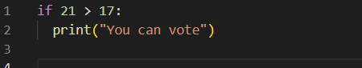

Python will give you a syntax error if you skip the indentation:

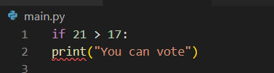

The number of spaces is up to you as a programmer, the most common use is four, but it has to be at least one.

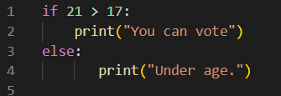

You must use the same number of spaces in the same block of code, otherwise Python will give you an error:

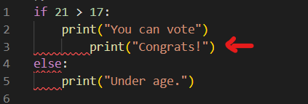

### **Comments**

Python has commenting capability for the purpose of in-code documentation. Comments can be used to explain Python code. Comments can be used to make the code more readable. Comments can be used to prevent execution when testing code. A comment does not have to be text that explains the code, it can also be used to prevent Python from executing code. Comments start with a #, and Python will render the rest of the line as a comment, and Python will ignore them:

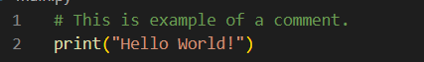

Comments can be placed at the end of a line, and Python will ignore the rest of the line:



#### **Multi Line Comments**

Python does not really have a syntax for multi-line comments. To add a multiline comment, you could insert a # for each line:

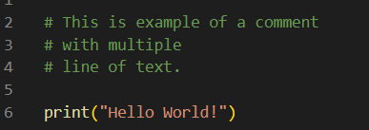

Or, not quite as intended, you can use a multiline string.

Since Python will ignore string literals that are not assigned to a variable, you can add a multiline string (triple quotes) in your code, and place your comment inside it:

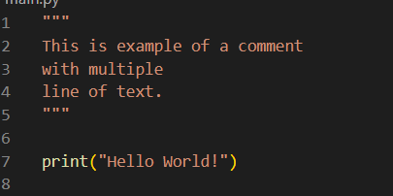

### **Variable**

One of the most powerful features of a programming language is the ability to manipulate variables. A variable is a name that refers to a value. The variables hold values (data).

* Variables are containers for storing data values.
* A variable is created the moment you first assign a value to it.
* Python has no command for declaring a variable.

Example:

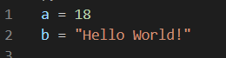

**Naming and Using Variables**

When you’re using variables in Python, you need to adhere to a few rules and guidelines. Breaking some of these rules will cause errors; other guidelines just help you write code that’s easier to read and understand. Be sure to keep the following variable rules in mind:

* Variable names can contain only **letters**, **numbers**, and **underscores**. They can **start** with a **letter** or an **underscore**, but **not with a number**. For instance, you can call a variable ***message_1*** but not ***1_message***.
* **Spaces** are **not allowed** in variable names, but underscores can be used to separate words in variable names. For example, ***greeting_message*** works, but ***greeting message*** will cause errors.
* Avoid using Python **keywords** and function names as variable names; that is, do not use words that Python has reserved for a particular programmatic purpose, such as the word ***print***. (You will learn “Python Keywords and Built-in Functions” on other lessons.)
* Variable names should be short but descriptive. For example, ***name*** is better than ***n***, ***student_name*** is better than ***s_n***, and ***name_length*** is better than ***length_of_persons_name***.
* Be careful when using the lowercase letter ***l*** and the uppercase letter ***O*** because they could be confused with the numbers **1** and **0**.

Variables do not need to be declared with any particular type, and can even change type after they have been set.

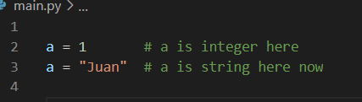

Variable names are case-sensitive.

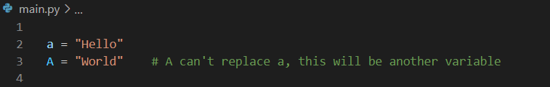

You can assign a variable as value of another variable

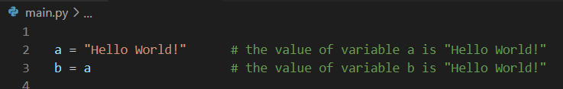

### **Datatypes**

Datatype is set of data with predefined values. The Type of data stored in a variable.

Two types of datatypes:

1. System-defined datatypes (also called primitive datatypes)
2. User-defined datatypes

#### **Built-in Data Types**

In programming, data type is an important concept. Variables can store data of different types, and different types can do different things. Python has the following data types built-in by default, in these categories:

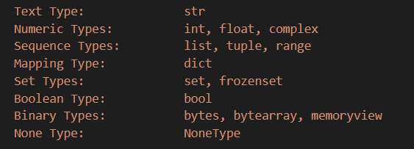

#### **Get the Type**

You can get the data type of a variable with the **type()** function.

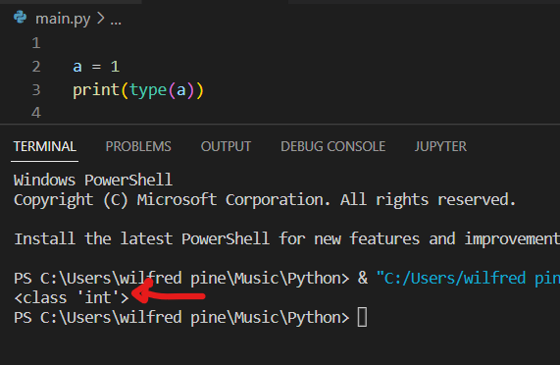

#### **Setting the Data Type**

In Python, the data type is set when you assign a value to a variable: Python will automatically define what kind of data you store in a variable.

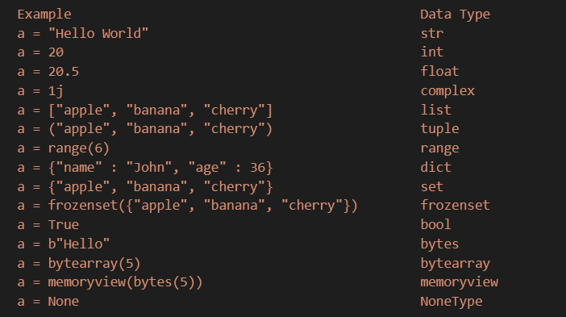

##### **String**

Series of characters interpreted as text. String variables can be declared either by using single or double quotes:

**'hello'** is the same as **"hello"**

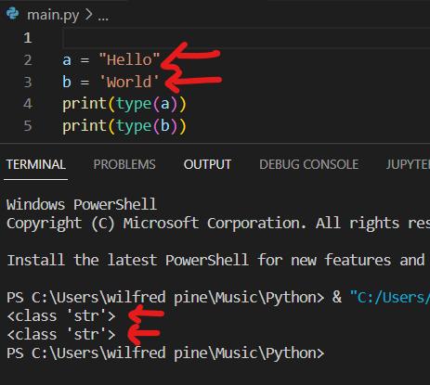

###### **Raw String**

To represent special characters such as tabs and newlines, Python uses the backslash (\) to signify the start of an escape sequence. For example:

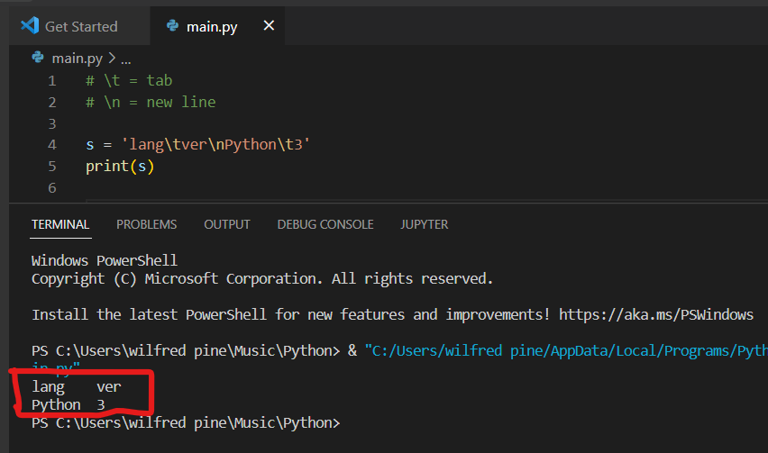

In a regular string, Python counts an escape sequence as a single character:

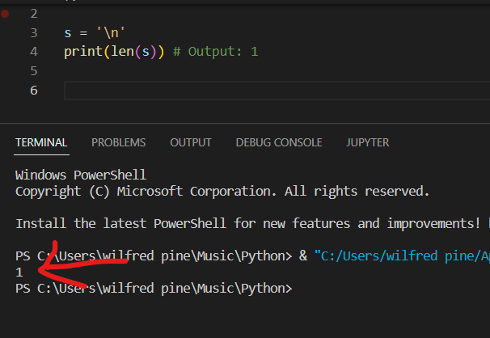

Meaning, the character after a back slash (\) only display or count. So, when you want to read the back slash in a string, you need to put backslash two times to read the second backslash (\\).

**Using single backslash**

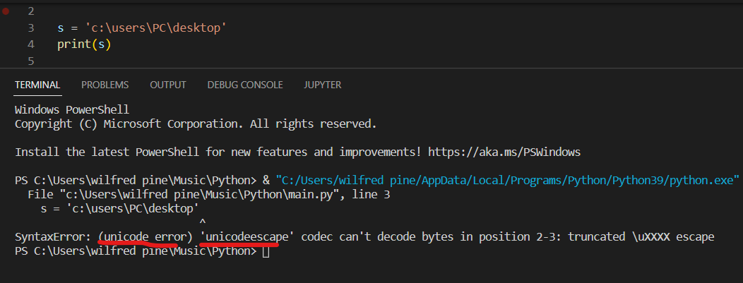

**Using Double backslash**

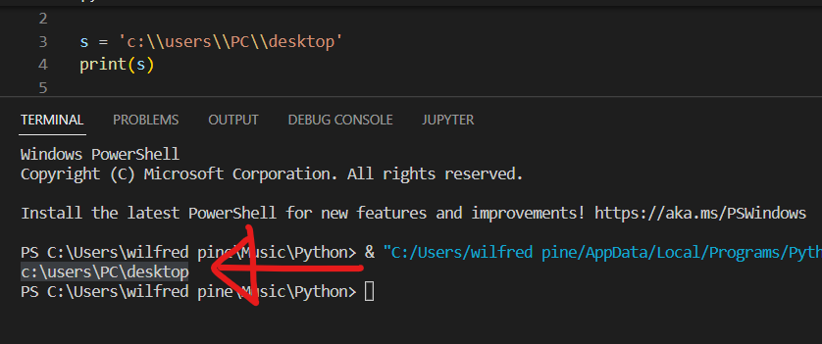

**Using Raw String**

However, raw strings treat the backslash (\) as a literal character. For example:

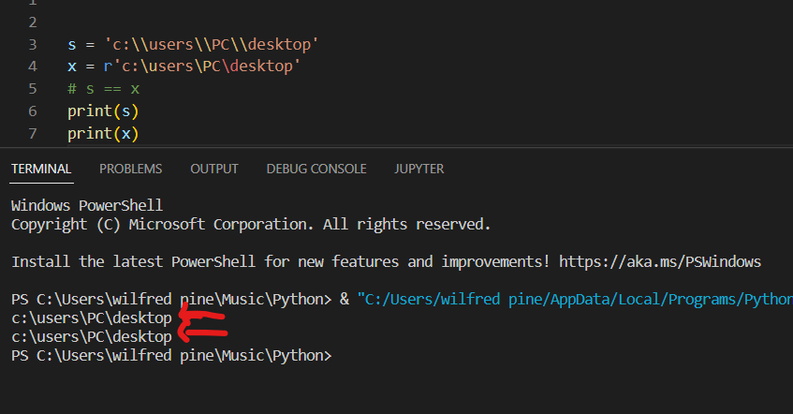

###### **Multiline Strings**

You can assign a multiline string to a variable by using three quotes:

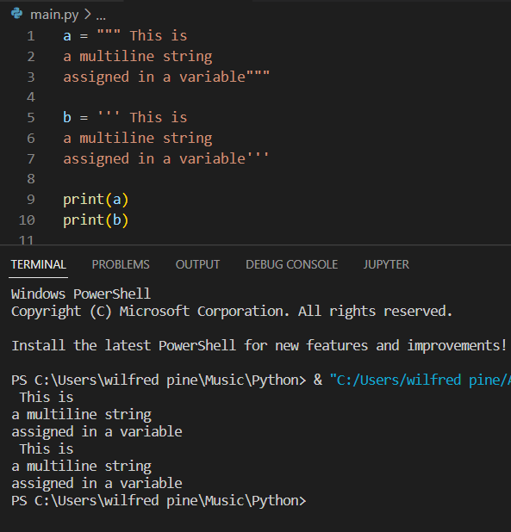

Note: You will learn more about strings in string functions lessons.

##### **Integer**

When an integer is enclosed by single or double quotation, python read it as string.

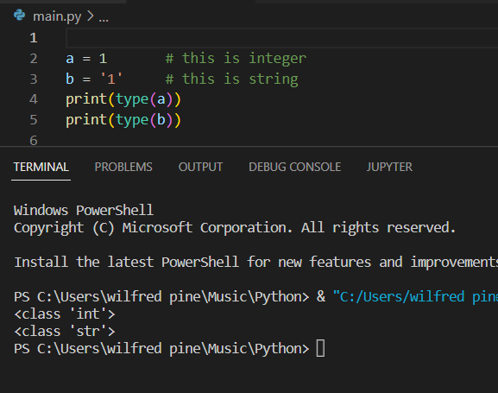

#### **Setting the Specific Data Type**

If you want to specify the data type, you can use the following **constructor functions**:

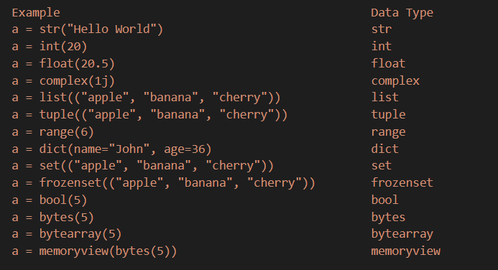

Example:

The **b** value is a string, and the **c** is integer, then **d** is float.

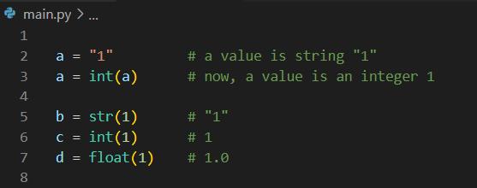

### **Casting / Type Casting**

Converting one data type to another is known as casting. Python is an object-orientated language, and as such it uses classes to define data types, including its primitive types. Casting in python is therefore done using constructor functions.

Example: The value of variable ***a*** is *string* and convert it into *integer* using the **int()** constructor function.



### **Operators**

Operators are used to perform operations on variables and values. Python divides the operators in the following groups:

* Arithmetic operators
* Assignment operators
* Comparison operators
* Logical operators
* Identity operators
* Membership operators
* Bitwise operators

#### **Python Arithmetic Operators**

Arithmetic operators are used with numeric values to perform common mathematical operations:

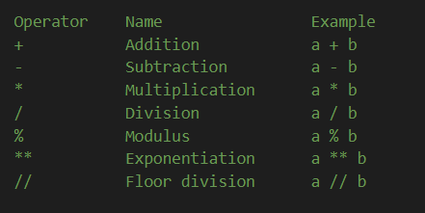

#### **Python Assignment Operators**

Assignment operators are used to assign values to variables:

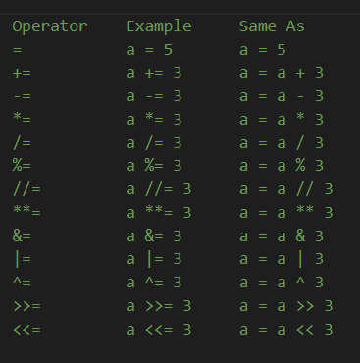

#### **Python Comparison Operators**

Comparison operators are used to compare two values:

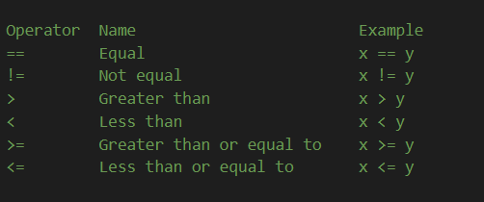

#### **Python Logical Operators**

Logical operators are used to combine conditional statements:

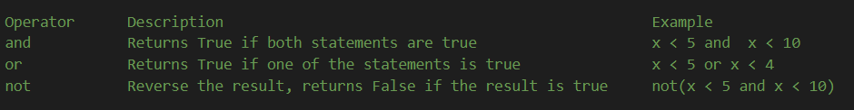

#### **Python Identity Operators**

Identity operators are used to compare the objects, not if they are equal, but if they are the same object, with the same memory location:

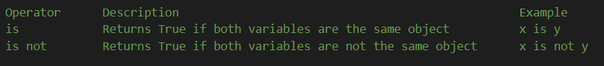

#### **Python Membership Operators**

Membership operators are used to test if a sequence is presented in an object:



#### **Python Bitwise Operators**

Bitwise operators are used to compare (binary) numbers:

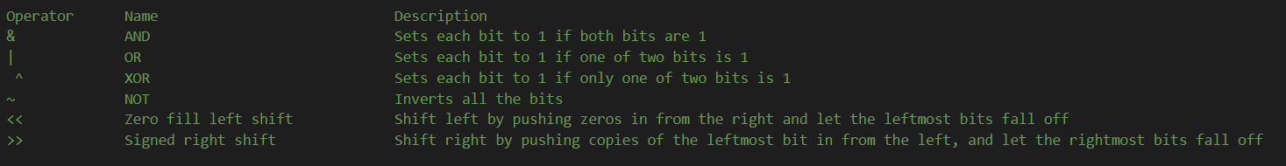

### **Expression**

An **Expression** is a sequence or combination of values, [variables](https://codepict.com/python-variables/), [operators](https://codepict.com/python-operators-everything-you-need-to-know/) and [function](https://www.w3schools.com/python/python_functions.asp) calls that always produces or returns a result value.

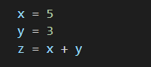

In the above example x, y and z are variables, 5 and 3 are values, = and + are operators.

So, the first combination x = 5 is an expression, the second combination y = 3 is an another expression and at last, z = x + y is also an expression.

An Expression always evaluates (calculate) to itself.

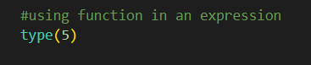

### **Statements**

Any ***Instruction*** that a python interpreter can execute (carry out) is called a **Statement**. An Instruction is an order/command given to a computer processor by a computer program to perform some mathematical or logical manipulations (calculations). Each line or a sentence in any programming language is called an instruction.

A Statement is the smallest executable unit of code that has an effect, like creating a variable or displaying a value. Each line of code that we write in any programming language is called a statement. Because all the lines are executable by the interpreter or the compiler of that programming language.

### **Identifiers**

Variable name is known as identifier. There are few rules that you must follow while naming the variables in Python. For example, here the variable is of integer type that holds the value 10. The name of the variable, which is num is called identifier.

Num = 10

### **Concatenation**

String concatenation means add strings together. Use the **+** character to add a variable to another variable or a value to another value:

Example:

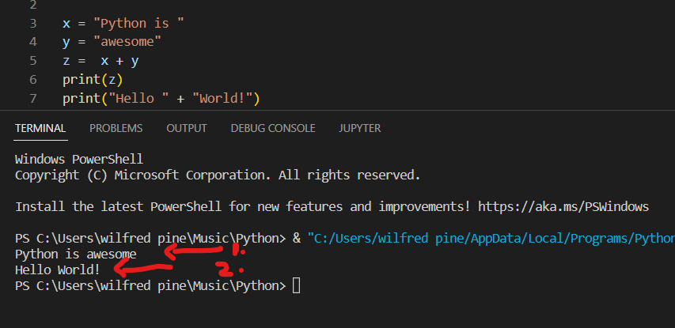

You can also concatenate a string into a variable.

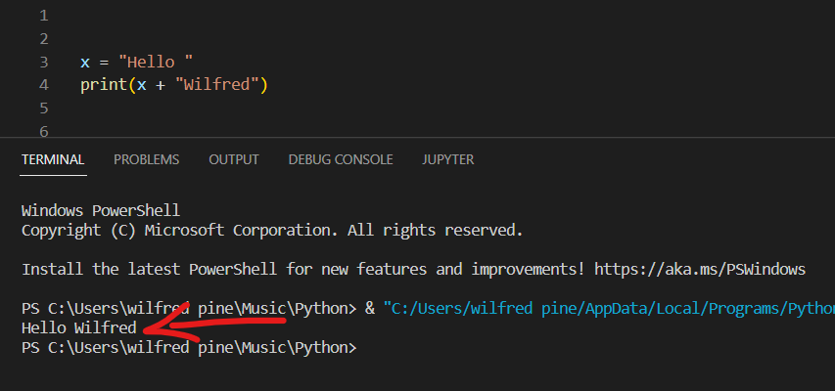

For numbers, the **+** character works as a mathematical operator:

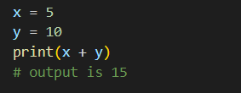

If you try to combine a string and a number, Python will give you an error:

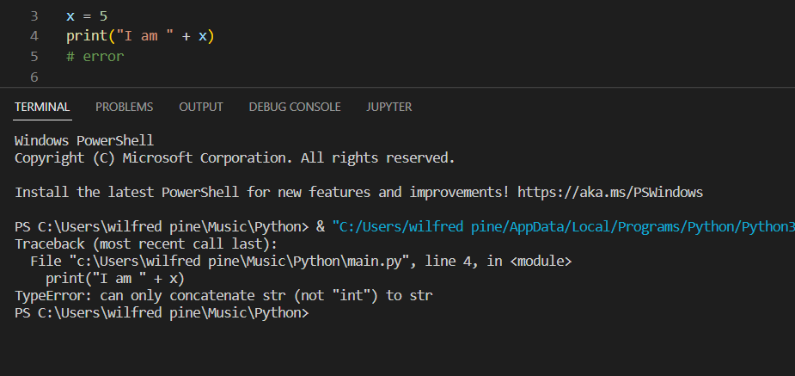

So, to concatenate a string into a number or integer value, you need to cast it into string using str function:

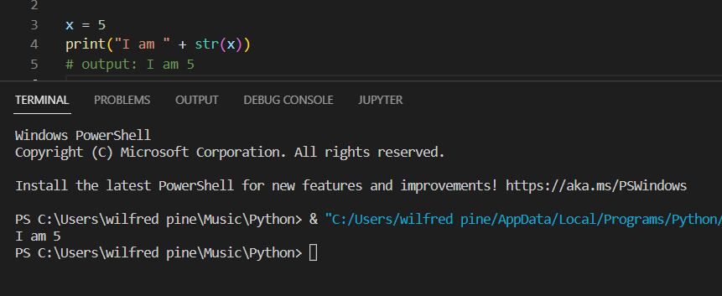

#### **String Formatting / Placeholders**

The placeholders can be identified using named indexes {name}, numbered indexes {0}, or even empty placeholders {}.

##### **format()**

The format() method allows you to format selected parts of a string. Sometimes there are parts of a text that you do not control, maybe they come from a database, or user input?

###### **Empty placeholders**

To control such values, add placeholders (curly brackets {}) in the text, and run the values through the format() method:

Example:

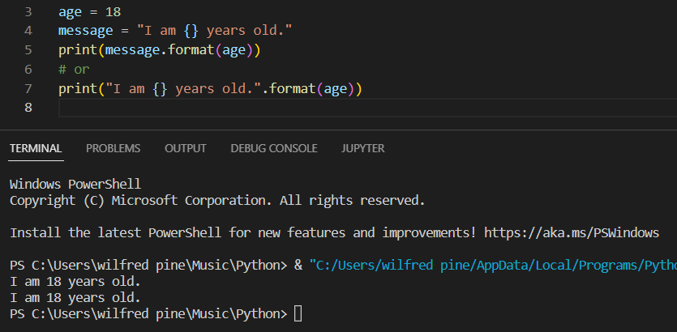

You can add parameters inside the curly brackets to specify how to convert the value: More parameters formatting type on *https://www.w3schools.com/python/ref_string_format.asp*

Example:

Format the price to be displayed as a number with two decimals:

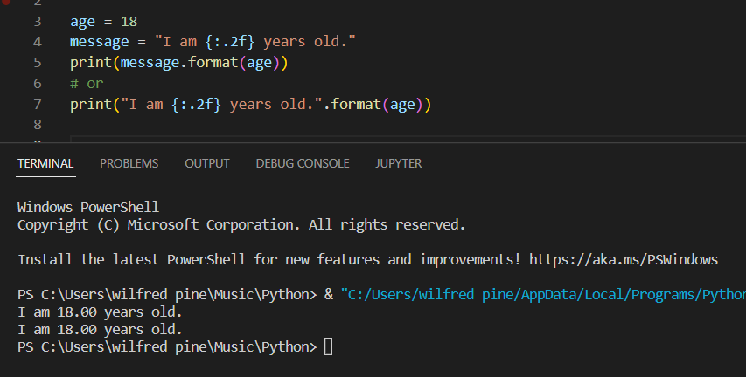

For multiple empty placeholders, the first parameter of format() method will be the first value of the first placeholders. It depends on order of format parameters.

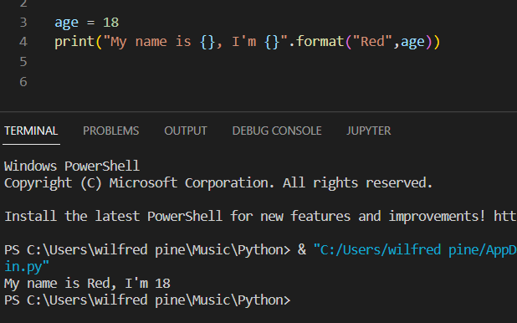

###### **Numbered Index placeholders**

You can use index numbers (a number inside the curly brackets {0}) to be sure the values are placed in the correct placeholders:

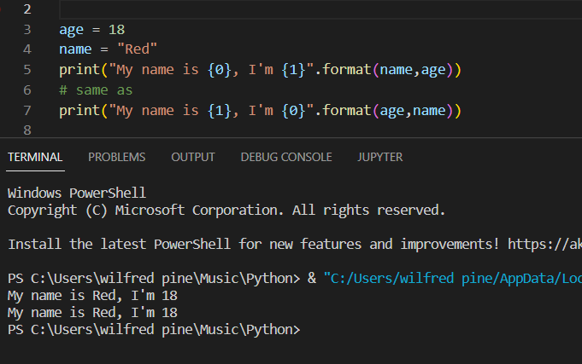

Also, if you want to refer to the same value **more than once**, use the index number:

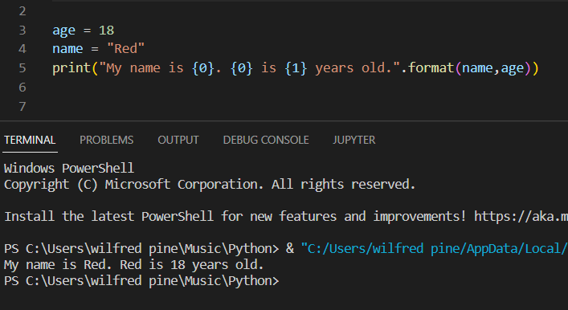

###### **Named Indexes placeholders**

You can also use named indexes by entering a **name inside the curly brackets** {carname}, but then you must use names when you pass the parameter values “My name is {name}”.format(name = "Red"):

Example:

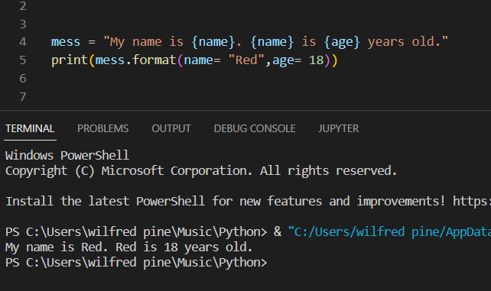

##### **String %**

Strings in Python have a unique built-in operation that can be accessed with the % operator. This lets you do simple positional formatting very easily.

String (%s) and Float(%f)

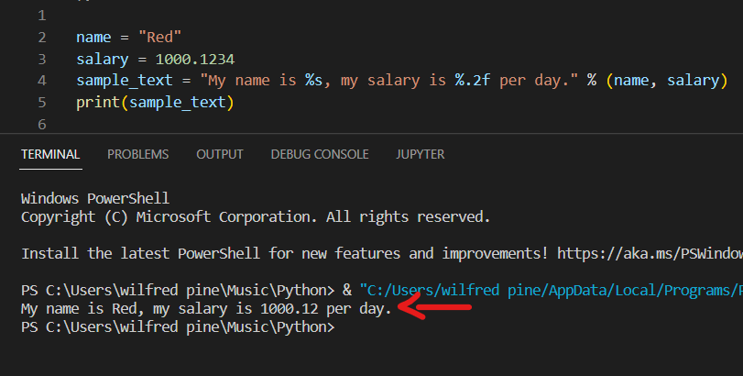

You can add numbers in String (%s) placeholders to insert a whitespace before and after of a string. %10s added spaces before the string value, and -10s added spaces after the string value.

Character (%c)

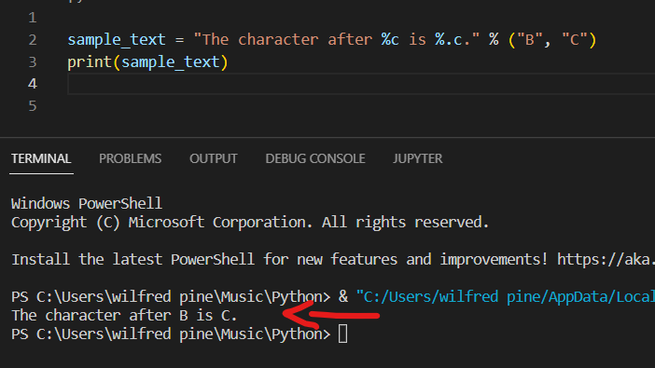

##### **f-Strings**

Also called “formatted string literals,” f-strings are string literals that have an f at the beginning and curly braces containing expressions (e.g.: variable, function, etc.) that will be replaced with their values.

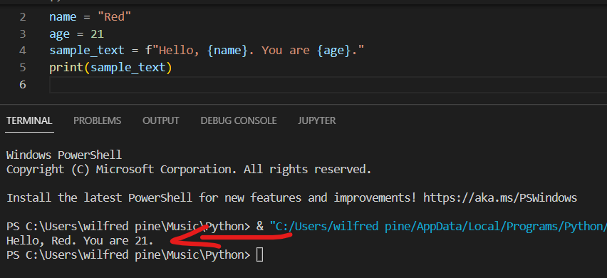

Examples:

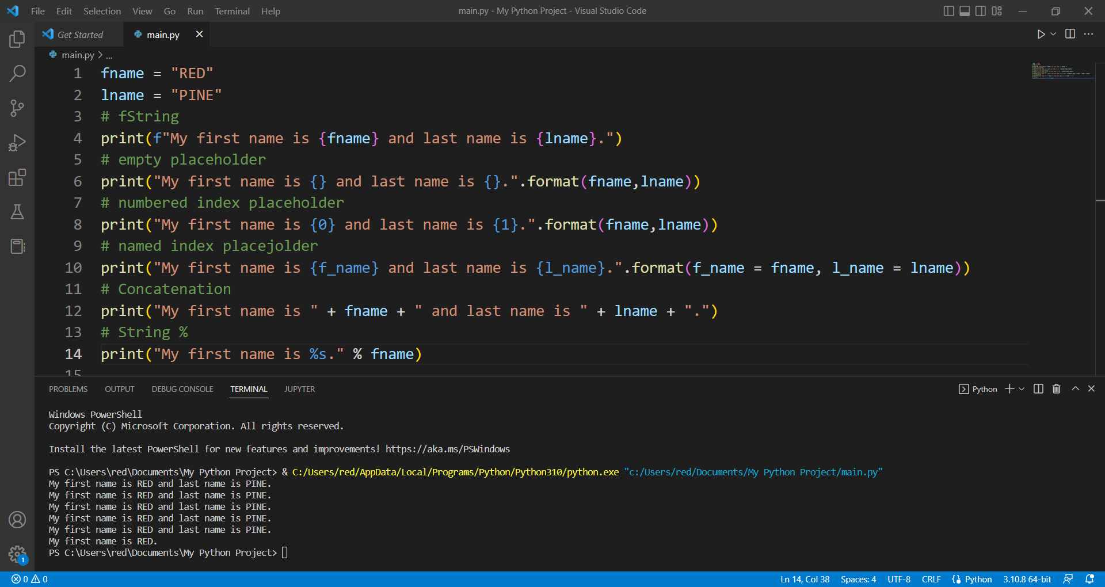

### **Keywords**

Python has a set of keywords that are reserved words that cannot be used as variable names, function names, or any other identifiers:

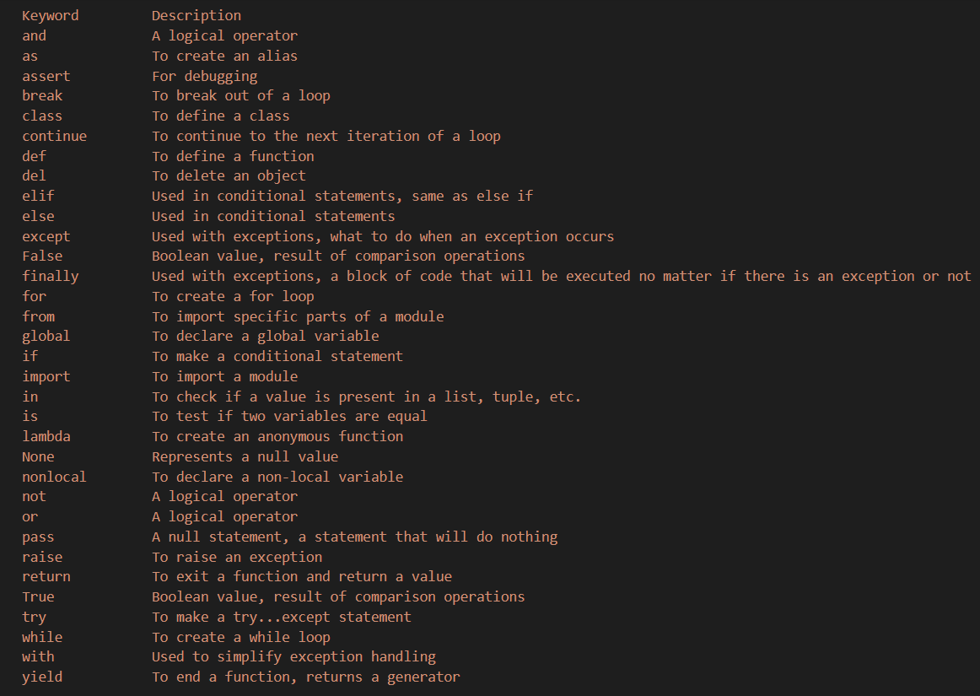

### **Getting User Input**

Python allows for user input. That means we can ask the user for input. The method is a bit different in Python 3.6 than Python 2.7. Python 3.6 uses the **input()** method. Python 2.7 uses the **raw_input()** method.

The following example asks for the username, and when you entered the username, it gets printed on the screen.

Python 3.6

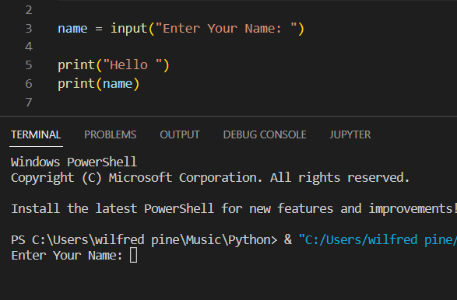 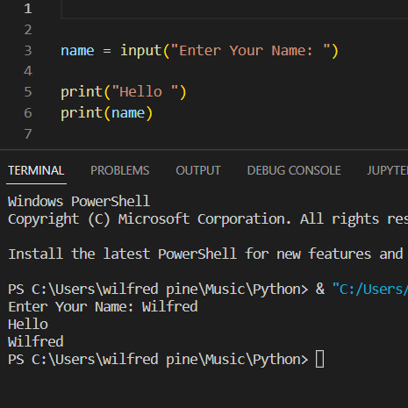

Note: Python stops executing when it comes to the input() function, and continues when the user has given some input.

# **Control Structures**

A control structure (or flow of control) is a block of programming that analyses variables and chooses a direction in which to go based on given parameters.

The basic decision-making process in programming and flow of control determines how a computer program will respond when given certain conditions and parameters.

## **Types of Control Structure**

1. **Sequential** - Sequential execution is when statements are executed one after another in order. You don't need to do anything more for this to happen.
2. **Selection** - Selection used for decisions, branching –choosing between 2 or more alternative paths.
3. **Iteration** - Repetition used for looping, i.e. repeating a piece of code multiple times in a row.

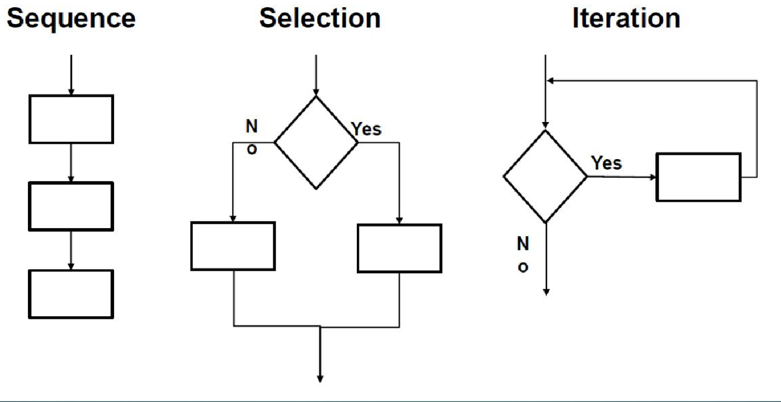

### **Sequence**

* The simplest structure
* Control flows from one statement to the next
* Statements are executed sequentially in the order in which they appear in the program

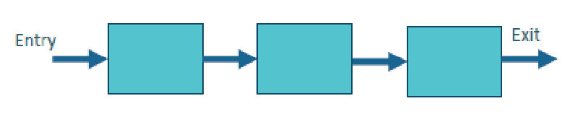 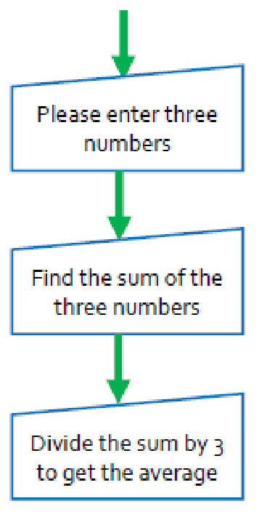

Example:

A program that computes and prints the net pay of an employee contains the following code:

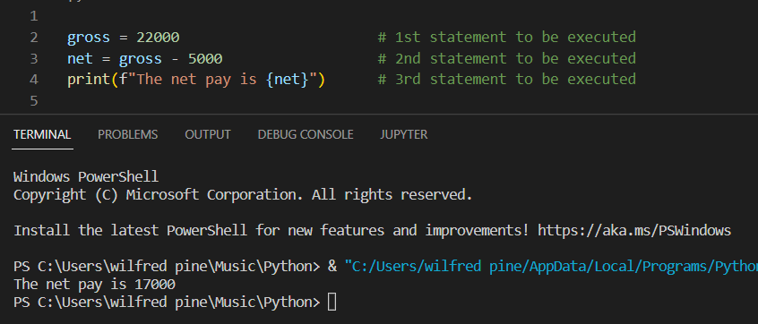

### **Selection**

The selection statements are also known as decision making statements or branching statements. Provides a choice between two alternatives.

3 Components

1. A condition to be tested
2. The statement to be performed if the condition is satisfied (process A)
3. The statement to be performed if the condition is not satisfied (process B)

Entry to the structure is through the condition. Exit is through the execution of process A or process B

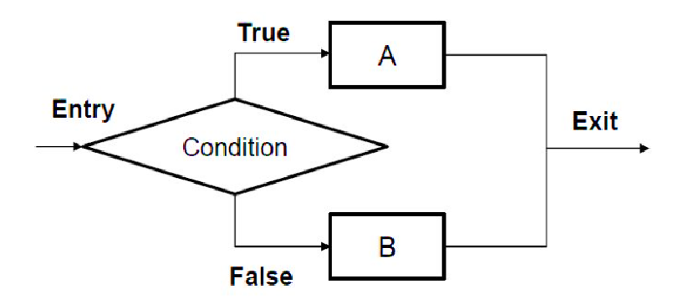

**Conditional Operators**

Python supports the usual logical conditions from mathematics:

* Equals: a == b
* Not Equals: a != b
* Less than: a < b
* Less than or equal to: a <= b
* Greater than: a > b
* Greater than or equal to: a >= b

These conditions can be used in several ways, most commonly in "if statements" and loops. An "if statement" is written by using the if keyword.

***Example for Program code for single alternative selection:***

#### The **if** statement

Example 1:

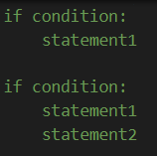

Example 2:



where condition is a Boolean expression or Boolean variable.

***Example for Program code for multiple true selection:***

#### The **elseif** and **else** statement:

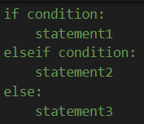

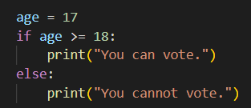

**Compound Conditions**

* Have more than 1 conditional expression
* The result of the compound expression depends on the individual result of each condition

The **AND** and **OR** keyword is a logical operator, and is used to combine conditional statements.

**Format:**

(condition1) **and** (condition2) – return True if the two condition are the same true.

(condition1) **or** (condition2) – return True if one of the two condition is true.

**Example:**

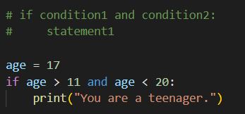

**Python Built-in Conditional Methods**

* isupper() - Returns **True** if all characters in the string are upper case
* islower() - Returns **True** if all characters in the string are lower case
* isdigit() - Returns **True** if all characters in the string are digits
* isalpha() - Returns **True** if all characters in the string are in the alphabet

#### **Nested If**

You can have if statements inside if statements, this is called nested if statements.

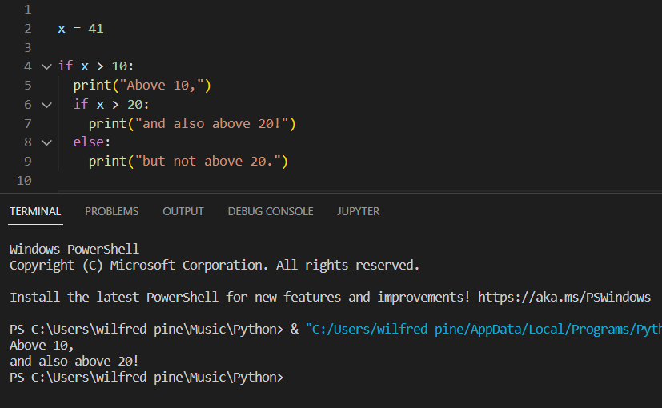

### **Iteration**

Most useful and powerful structure. Allows the repetition of instructions or statements in the loop body.

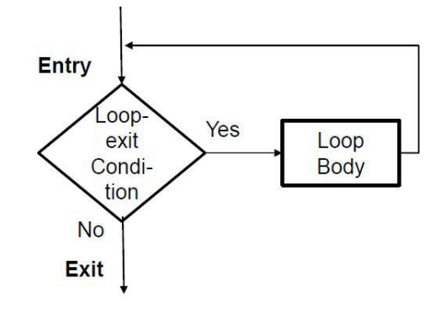

**Parts of the iteration structure**

* Loop body instruction(s) or statements which are repeated
* Loop-exit condition the condition to be tested before each repetition

#### **Types of Iteration**

* ***while* loop**
* ***for* loop**

Keywords used in ***for*** loop

* **In**
* **Range**

**When to use the while loop and the for loop?**

* Loops that are dependent on a sentinel value (or indicator) are better coded using a while loop
* The for loop is generally used for traversing and manipulating arrays
* When the number of times that the loop will be executed is known, the for loop provides a convenient shorthand.

**Common Loop Applications**

Using a loop to accumulate totals

* An accumulator is a variable that “sums up” or accumulates values
* It is like a counter whose values change each time the loop is entered. Counters, however, add a fixed value while accumulators accumulate undetermined values.

Using a loop to validate user entry

* Data entered by a user usually needs validation. It needs to be checked for errors. Incorrect data can lead to unwanted results and could end a program abnormally
* Usual checks for data are:
  + If it is the correct data type
  + For numeric data, if it is within an acceptable range of values

**Looping Examples:**

##### **While Loop**

With the while loop we can execute a set of statements as long as a condition is true.

Format:

while condition:

statement1

statement2

Example:

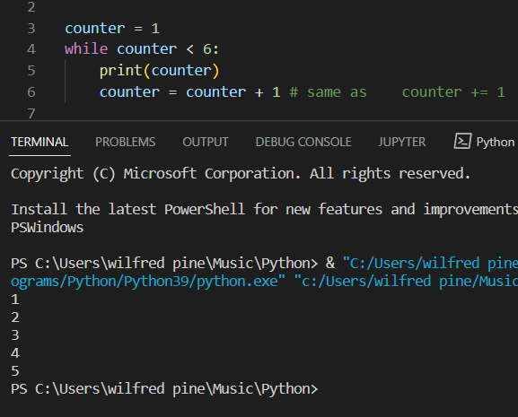

The statements inside the while loop are executed as long as the condition remains true. **R**emember to increment the counter variable, or else the loop will continue forever.

##### **For Loop**

A for loop is used for iterating over a sequence (that is either a list, a tuple, a dictionary, a set, or a string).

This is less like the for keyword in other programming languages, and works more like an iterator method as found in other object-orientated programming languages. With the for loop we can execute a set of statements, once for each item in a list, tuple, set etc.

Example of ***for*** loop using ***in*** keyword:

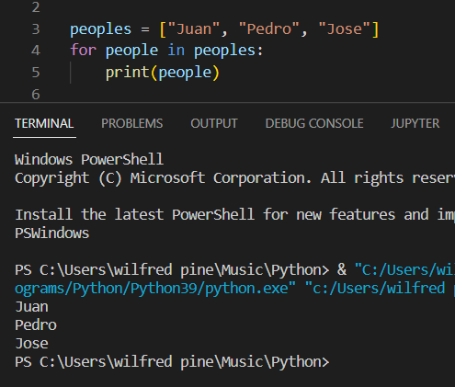

Example of ***for*** loop using ***range*** keyword:

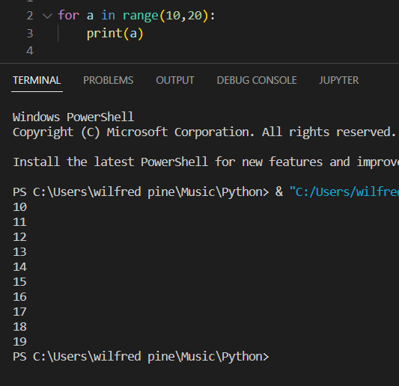 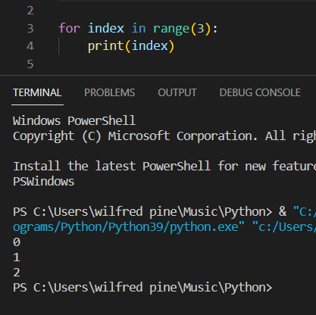

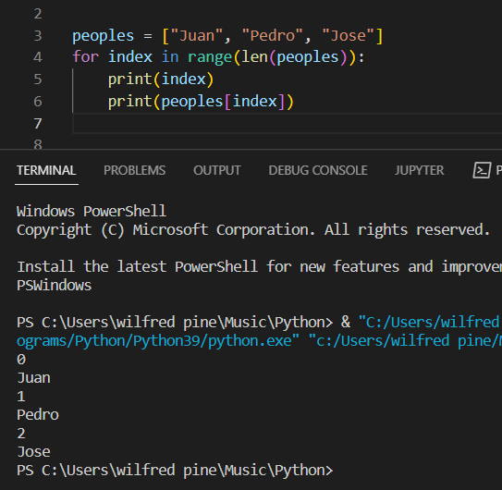

## **Break Statements**

* With the break statement we can stop the loop even if the while condition is true:
* force immediate termination of a loop, bypassing the conditional expression and any remaining code in the body of the loop
* The loop is terminated, and program control resumes at the next statement following the loop

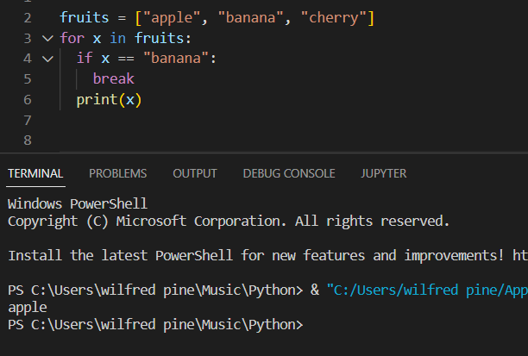 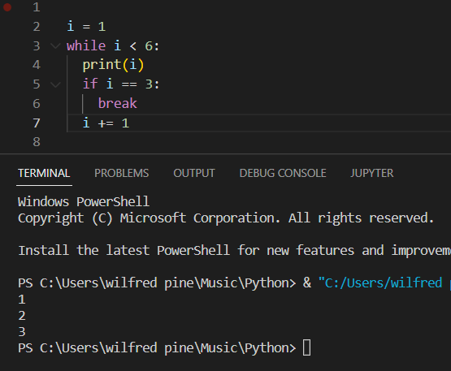

## **Continue Statements**

With the continue statement we can stop the current iteration, and continue with the next:

* In loops, a continue statement cause control to be transferred directly to the conditional expression that controls the loop.

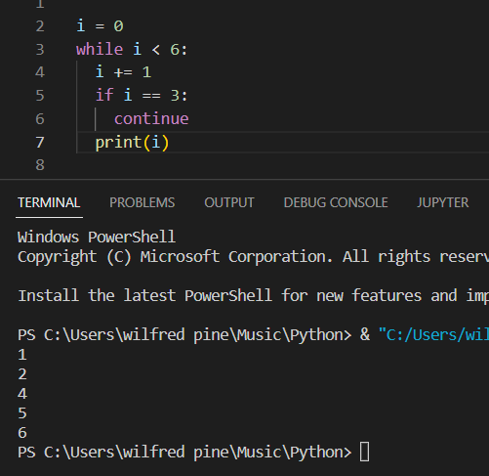 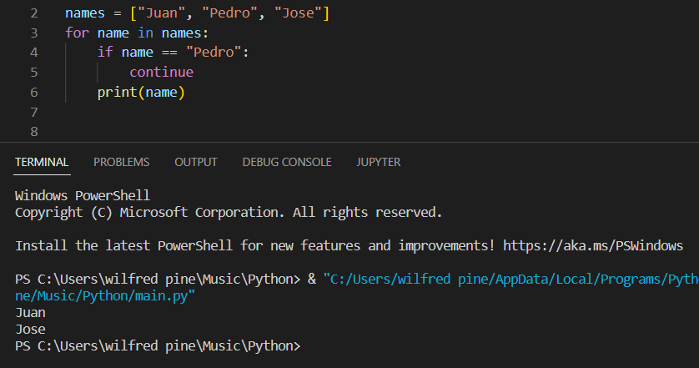

## **Else Statements**

With the else statement we can run a block of code once when the condition no longer is true:

Example:

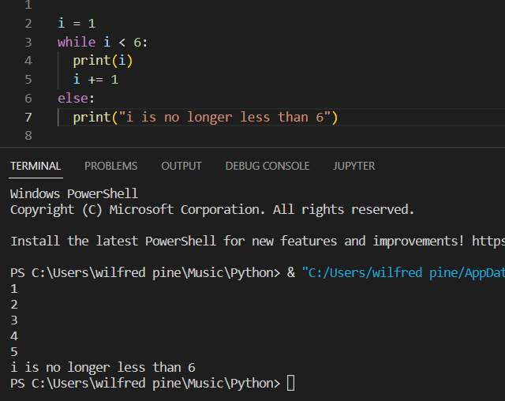

## **Pass Statements**

The pass statement is a null operation; nothing happens when it executes. The pass is also useful in places where your code will eventually go but has not been written yet.

The pass statement is used as a placeholder for future code.

When the pass statement is executed, nothing happens, but you avoid getting an error when empty code is not allowed. Empty code is not allowed in loops, function definitions, class definitions, or in if statements.

Example:

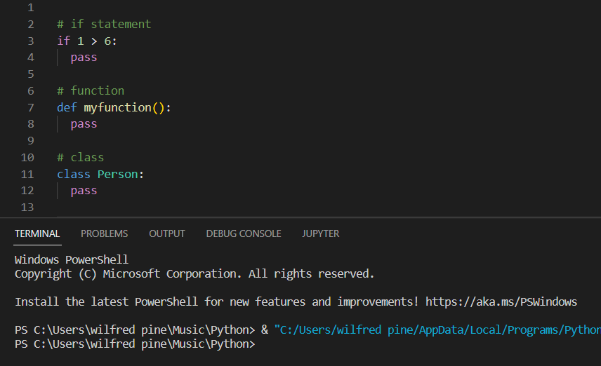

# **Python Data Structures**

## **User-Defined Data Structures**

* Stack
* Queue
* Tree
* Linked List
* Graph
* Hash Map

## **Built-in Data Structures or Python Collections (Arrays)**

There are four collection data types in the Python programming language:

* [**List**](https://www.w3schools.com/python/python_lists.asp) is a collection which is ordered and changeable. Allows duplicate members.
* [**Tuple**](https://www.w3schools.com/python/python_tuples.asp)is a collection which is ordered and unchangeable. Allows duplicate members.
* [**Set**](https://www.w3schools.com/python/python_sets.asp) is a collection which is unordered, unchangeable*, and unindexed. No duplicate members.
* [**Dictionary**](https://www.w3schools.com/python/python_dictionaries.asp) is a collection which is ordered** and changeable. No duplicate members.

### **List**

Lists are used to store multiple items in a single variable. Lists are one of 4 built-in data types in Python used to store collections of data, the other 3 are Tuple, Set, and Dictionary, all with different qualities and usage. Lists are created using **square brackets**:

Example:

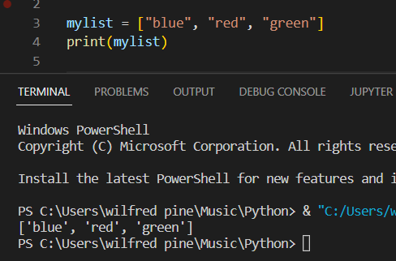

#### The list() Constructor

It is also possible to use the list() constructor when creating a new list.

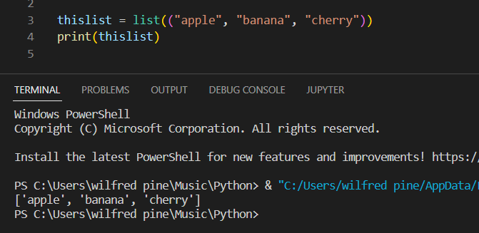

#### List Items

List items are **ordered**, **changeable**, and **allow duplicate values**. List items are indexed, the first item has index [0], the second item has index [1] etc.

**Ordered**

When we say that lists are ordered, it means that the items have a defined order, and that order will not change. If you add new items to a list, the new items will be placed at the end of the list.

**Note:** There are some [list methods](https://www.w3schools.com/python/python_lists_methods.asp) that will change the order, but in general: the order of the items will not change.

**Changeable**

The list is changeable, meaning that we can change, add, and remove items in a list after it has been created.

**Allow Duplicates**

Since lists are indexed, lists can have items with the same value:

Example:

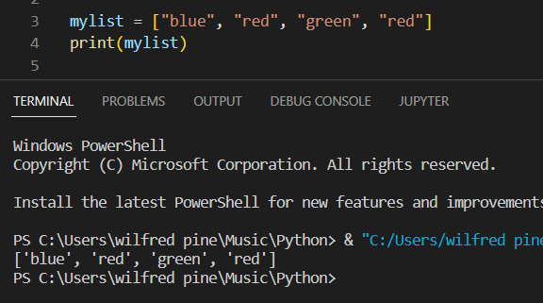

#### List Length

To determine how many items a list has, use the len() function:

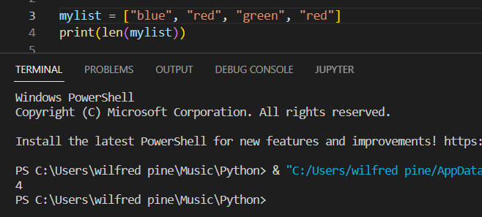

#### List Items - Data Types

List items can be of any data type:

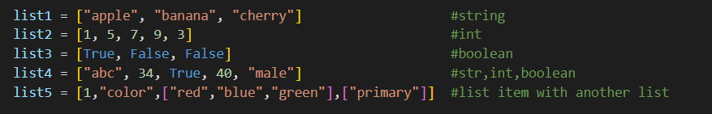

#### Access List Items

List items are indexed, and you can access them by referring to the index number:

Example:

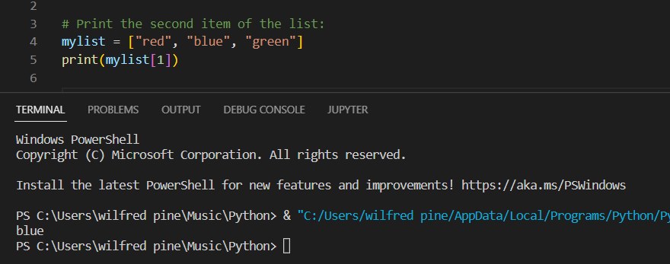

Note: The first item has index 0.

##### Negative Indexing

Negative indexing means start from the end.

-1 refers to the last item, -2 refers to the second last item etc.

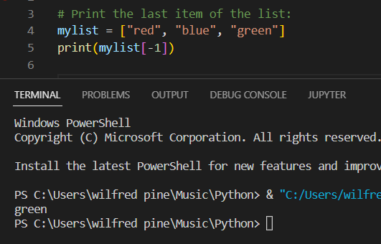

##### Range of Indexes

You can specify a range of indexes by specifying where to start and where to end the range. When specifying a range, the return value will be a new list with the specified items.

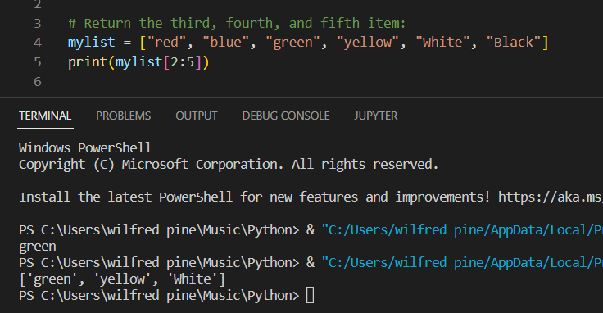

Note: Remember that the first item has index 0. The search will start at index 2 (included) and end at index 5 (not included).

*By leaving out the start value, the range will start at the first item:*

Example:

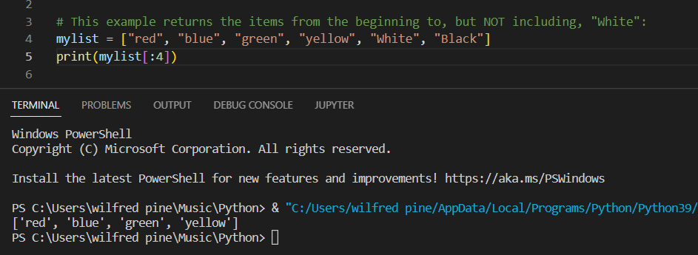

*By leaving out the end value, the range will go on to the end of the list:*

Example:

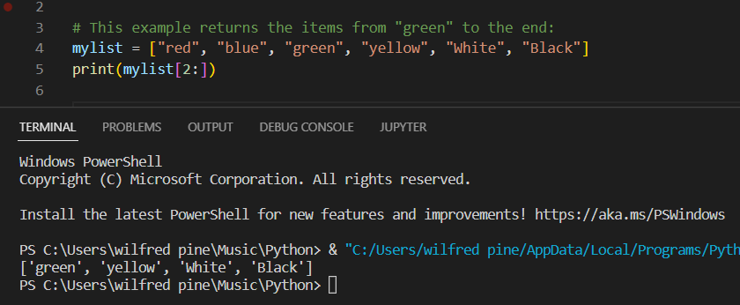

##### Range of Negative Indexes

Specify negative indexes if you want to start the search from the end of the list:

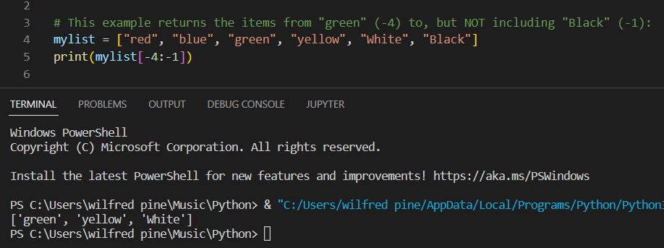

##### Check if Item Exists

To determine if a specified item is present in a list use the in keyword:

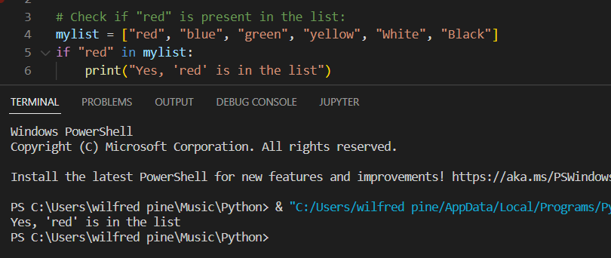

#### Change List Items

##### Change Item Value

To change the value of a specific item, refer to the index number:

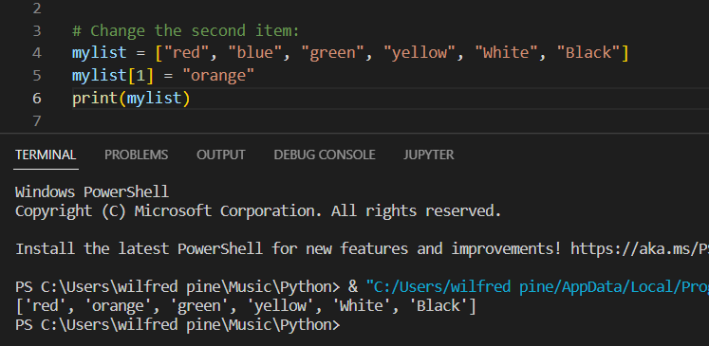

##### Change a Range of Item Values

To change the value of items within a specific range, define a list with the new values, and refer to the range of index numbers where you want to insert the new values:

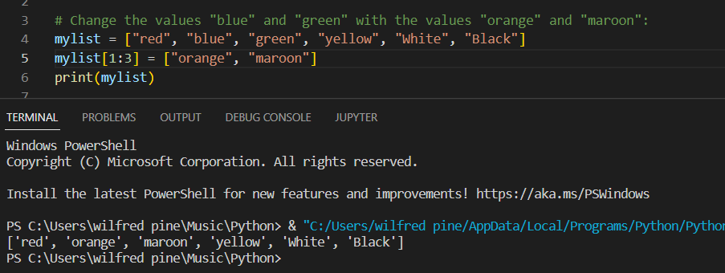

If you insert more items than you replace, the new items will be inserted where you specified, and the remaining items will move accordingly:

Example:

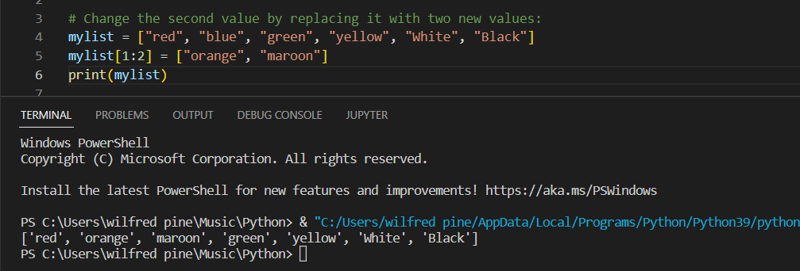

**Note:** The length of the list will change when the number of items inserted does not match the number of items replaced.

If you insert less items than you replace, the new items will be inserted where you specified, and the remaining items will move accordingly:

Example:

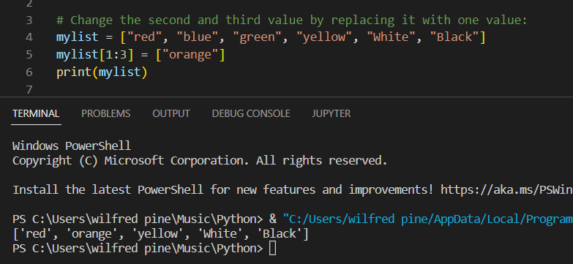

#### Add List Items

* Append items
* Insert items

##### Append Items

To add an item to the end of the list, use the append() method:

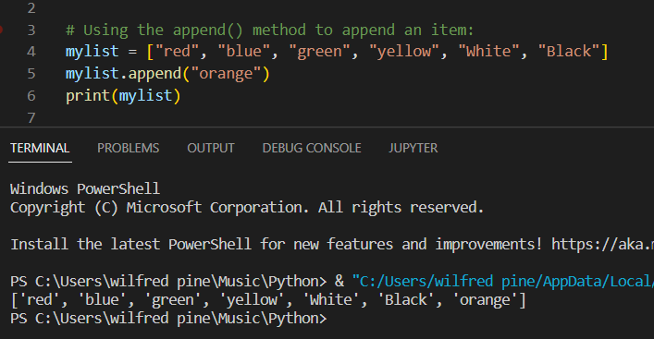

##### Insert Items

To insert a new list item, without replacing any of the existing values, we can use the insert() method.

The insert() method inserts an item at the specified index:

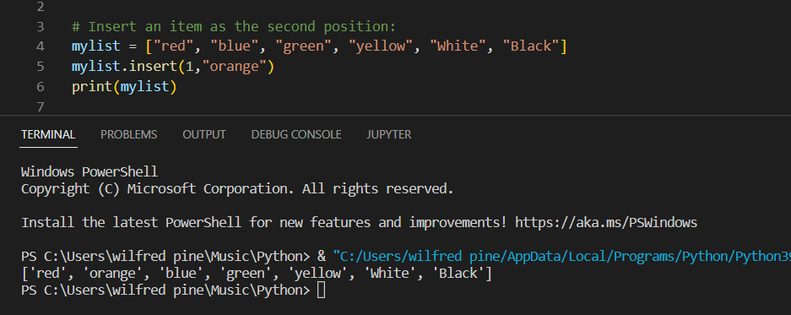

**Note:** As a result of the examples above, the lists will now contain 7 items.

##### Extend List

To append elements from another list to the current list, use the extend() method.

The elements will be added to the end of the list.

Example:

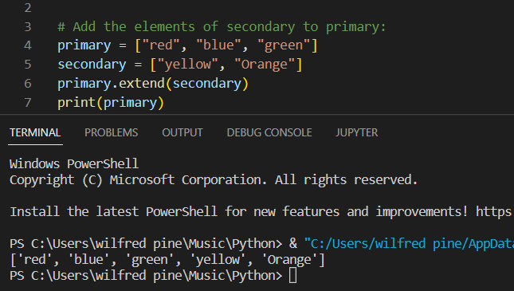

##### Add Any Iterable

The extend() method does not have to append lists, you can add any iterable object (tuples, sets, dictionaries etc.).

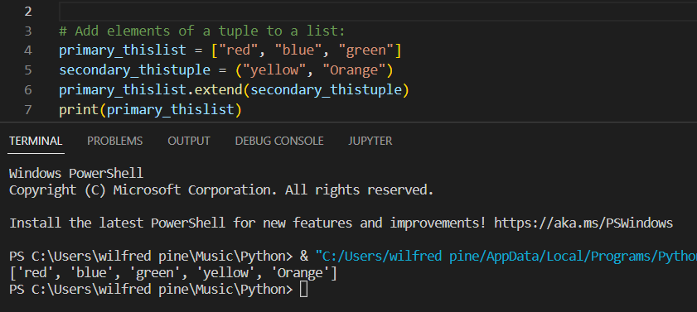

#### Remove List Items

##### Remove Specified Item

The remove() method removes the specified item.

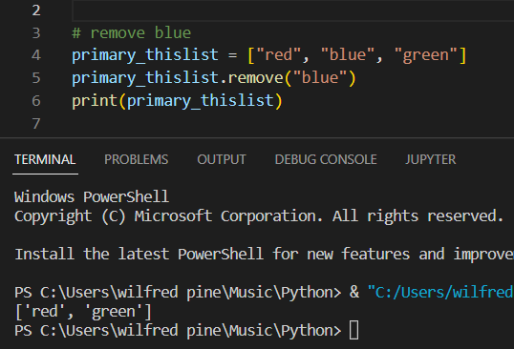

##### Remove Specified Index

The pop() method removes the specified index.

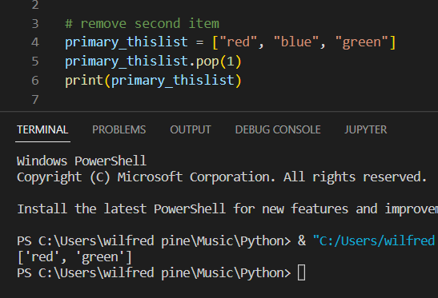

If you do not specify the index, the pop() method removes the last item.

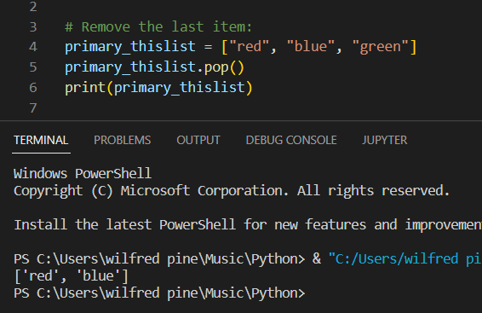

##### del Keyword

The *del* keyword also removes the specified index:

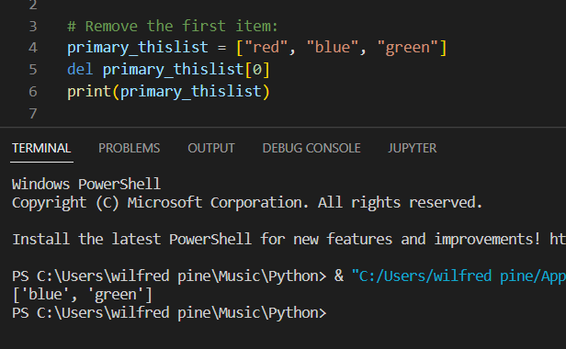

The *del* keyword can also delete the list completely.

Example

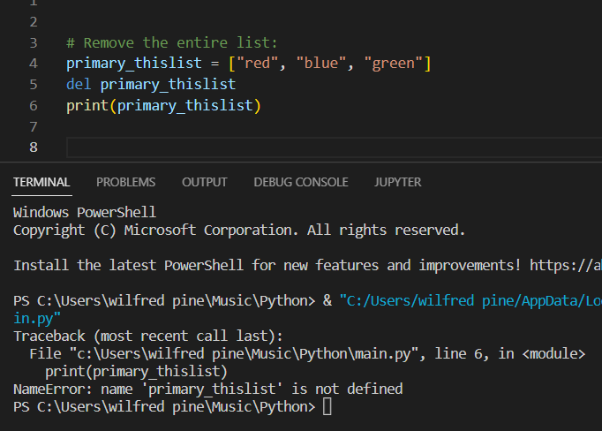

##### Clear the List

The *clear()* method empties the list. The list still remains, but it has no content.

Example:

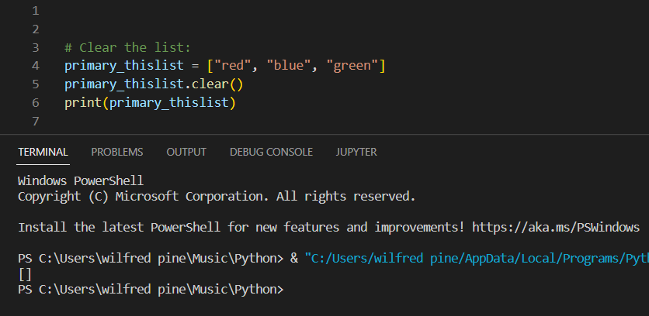

#### Loop Lists

##### Loop Through a List

You can loop through the list items by using a *for* loop:

Example:

Print all items in the list, one by one:

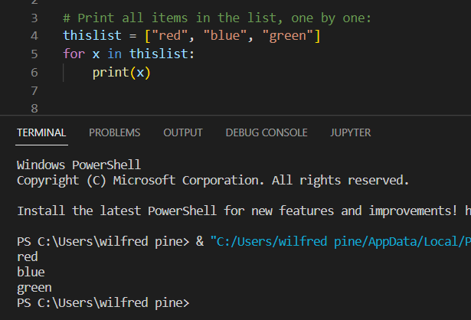

##### Loop Through the Index Numbers

You can also loop through the list items by referring to their index number.

Use the *range()* and *len()* functions to create a suitable iterable.

**Example**

Print all items by referring to their index number:

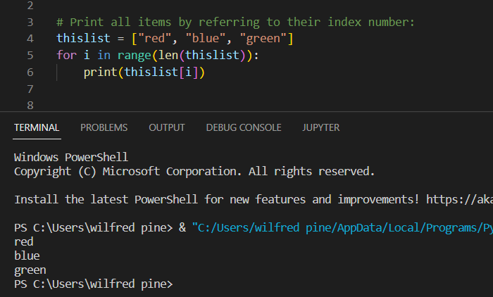

The iterable created in the example above is [0, 1, 2].

##### Using a While Loop

You can loop through the list items by using a while loop.

Use the *len()* function to determine the length of the list, then start at 0 and loop your way through the list items by referring to their indexes.

Remember to increase the index by 1 after each iteration.

**Example**

Print all items, using a *while* loop to go through all the index numbers

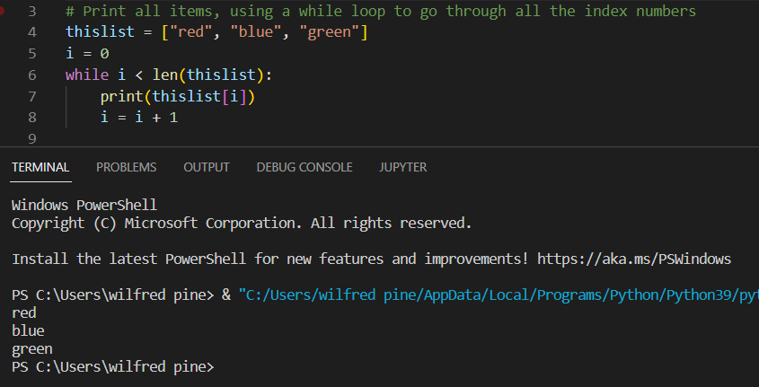

##### Looping Using List Comprehension

List Comprehension offers the shortest syntax for looping through lists:

**Example**

A shorthand *for* loop that will print all items in a list:

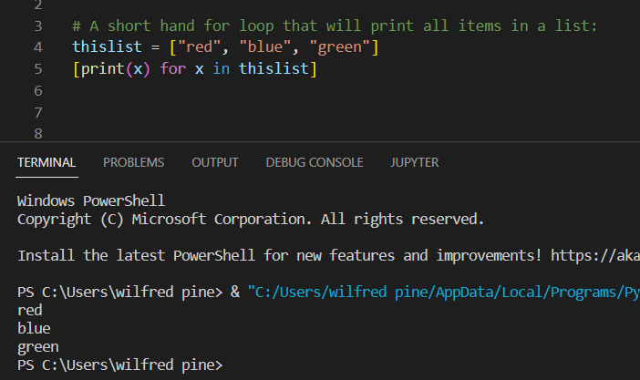

#### List Comprehension

List comprehension offers a shorter syntax when you want to create a new list based on the values of an existing list.

**Example:**

Based on a list of fruits, you want a new list, containing only the fruits with the letter "a" in the name. Without list comprehension you will have to write a for statement with a conditional test inside:

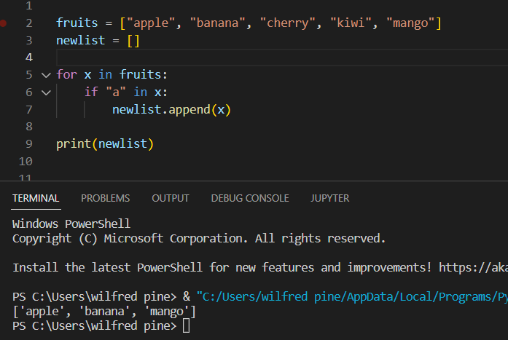

With list comprehension you can do all that with only one line of code:

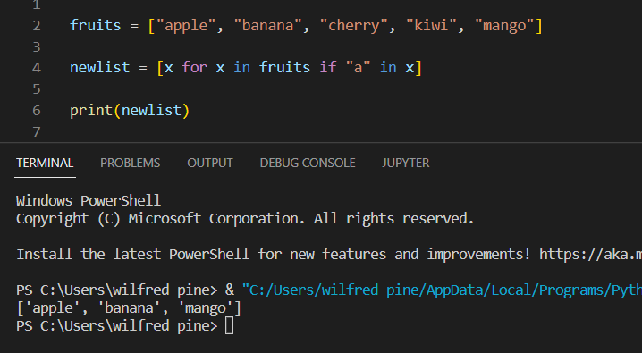

##### Syntax

newlist = [expression **for** item **in** iterable **if** condition == **True**]

The return value is a new list, leaving the old list unchanged.

###### Condition

The condition is like a filter that only accepts the items that valuate to *True*.

**Example**

Only accept items that are not "apple":

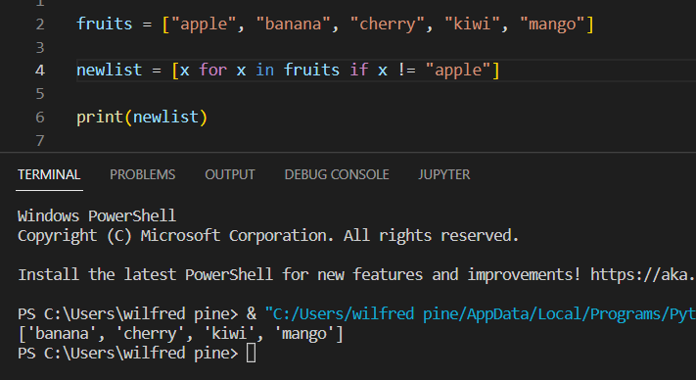

The condition if x != "apple"  will return *True* for all elements other than "apple", making the new list contain all fruits except "apple".

The *condition* is optional and can be omitted:

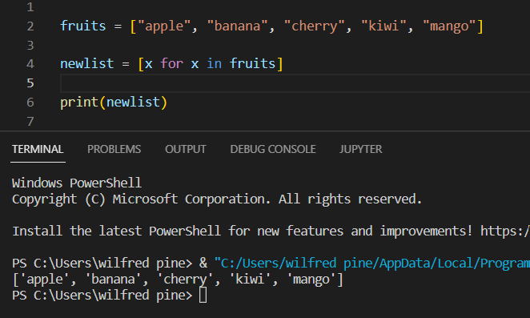

#### Sort Lists

**Sort List Alphanumerically**

List objects have a ***sort()*** method that will sort the list alphanumerically, ascending, by default:

Example:

Sort the list alphabetically:

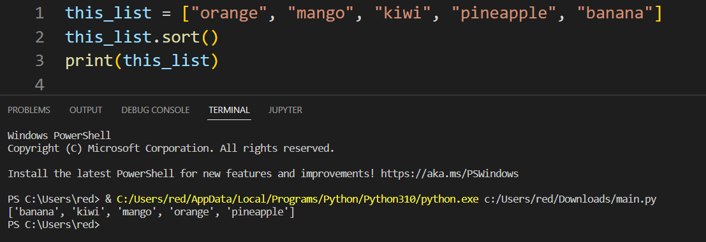

Sort the list numerically:

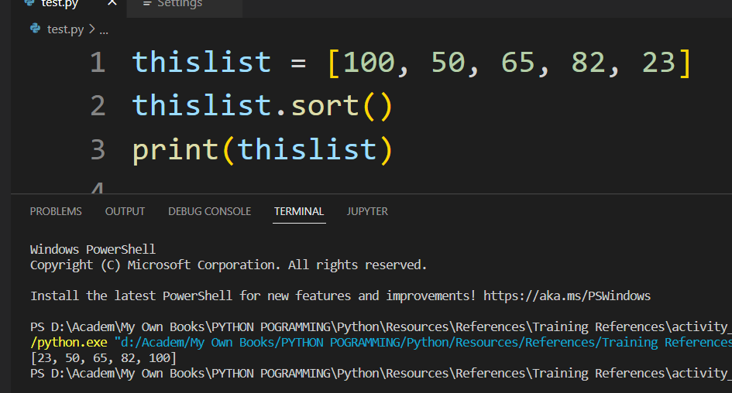

**Sort Descending**

To sort descending, use the keyword argument *reverse = True*:

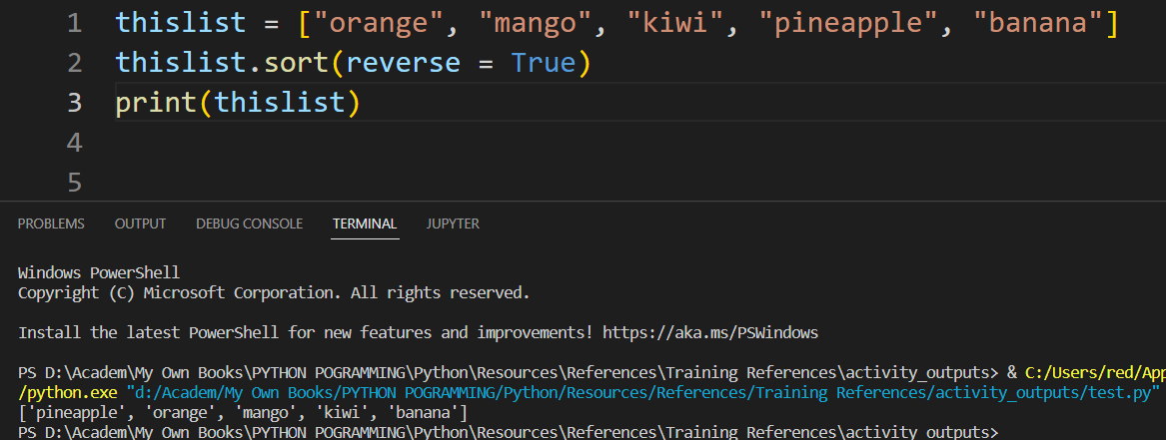

##### Customize Sort Function

You can also customize your own function by using the keyword argument key = function.

The function will return a number that will be used to sort the list (the lowest number first):

Sort the list based on how close the number is to 50:

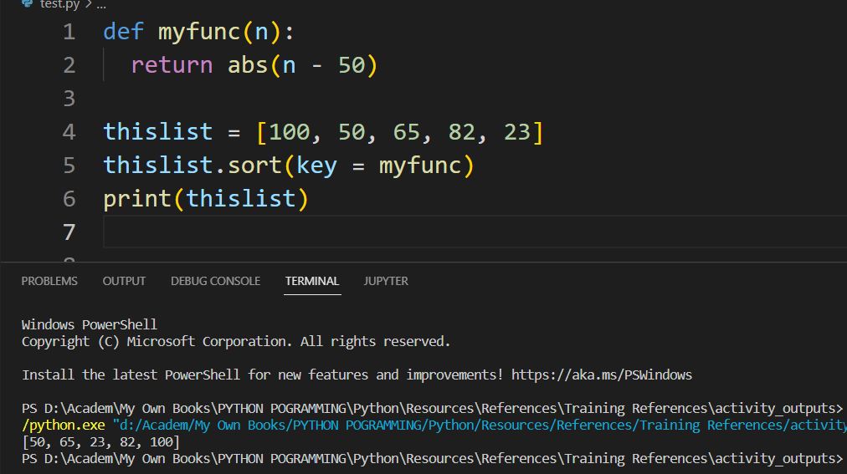

##### Case Insensitive Sort

By default the sort() method is case sensitive, resulting in all capital letters being sorted before lower case letters:

Case sensitive sorting can give an unexpected result:

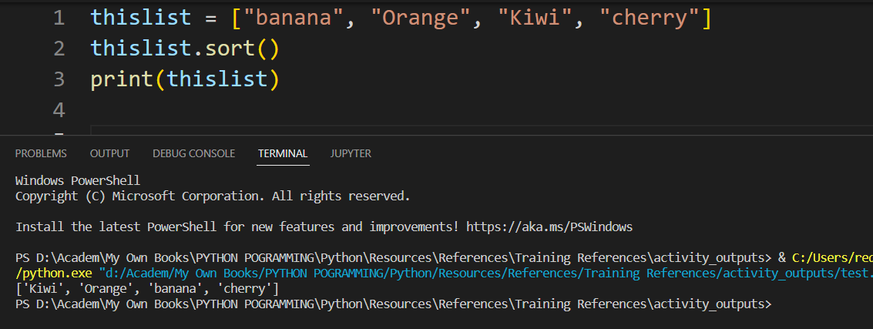

Luckily we can use built-in functions as key functions when sorting a list.

So if you want a case-insensitive sort function, use str.lower as a key function:

Perform a case-insensitive sort of the list:

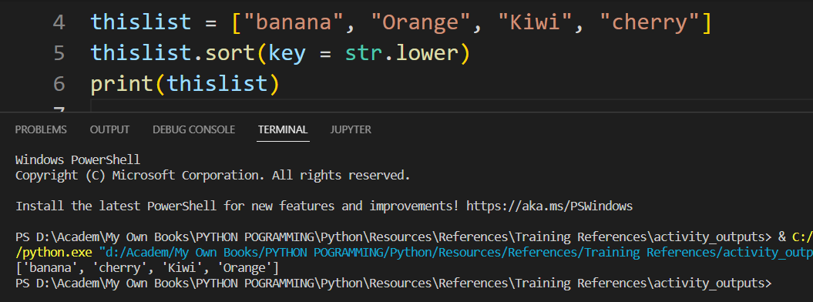

##### Reverse Order

What if you want to reverse the order of a list, regardless of the alphabet?

The *reverse()* method reverses the current sorting order of the elements.

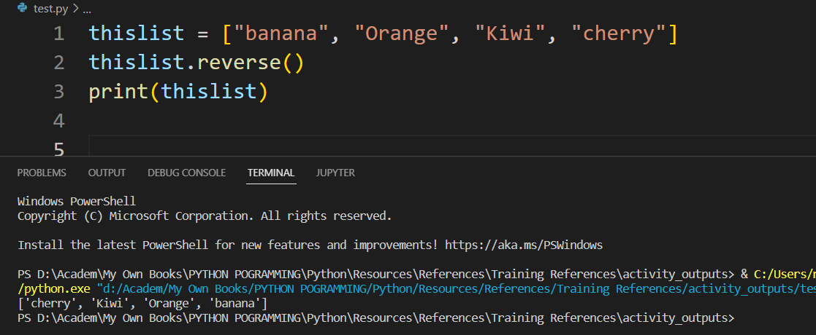

#### Copy Lists

Copy a List

You cannot copy a list simply by typing *list2 = list1*, because: *list2* will only be a reference to *list1*, and changes made in *list1* will automatically also be made in *list2*.

There are ways to make a copy, one way is to use the built-in List method *copy().*

Make a copy of a list with the *copy()* method:

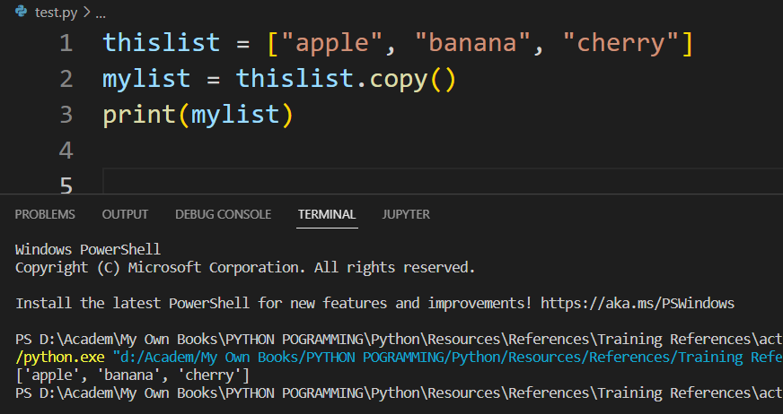

Another way to make a copy is to use the built-in method *list().*

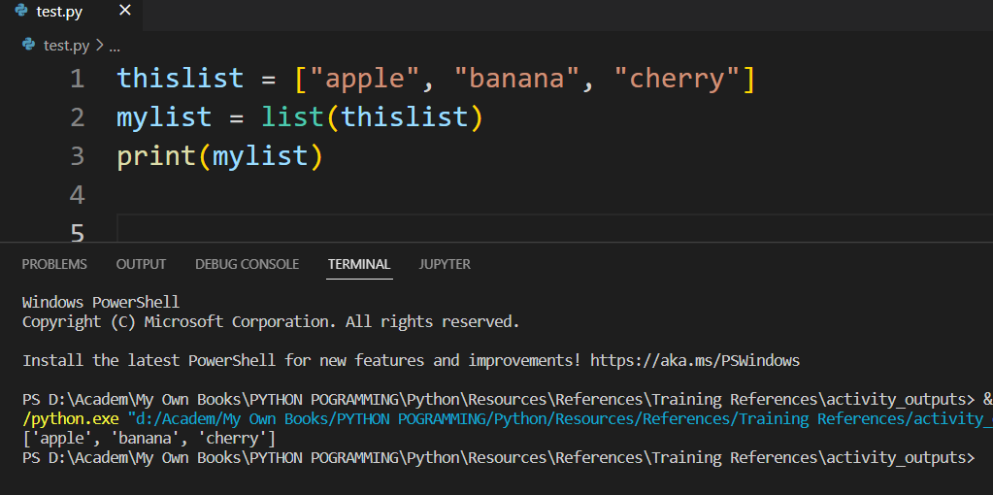

#### Join Lists

Join Two Lists

There are several ways to join, or concatenate, two or more lists in Python.

One of the easiest ways are by using the + operator.

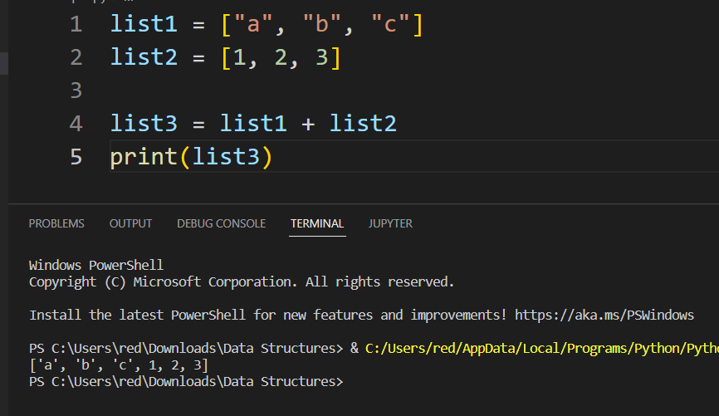

Or you can use the *extend()* method, which purpose is to add elements from one list to another list:

**Example**

Use the *extend()* method to add list2 at the end of list1:

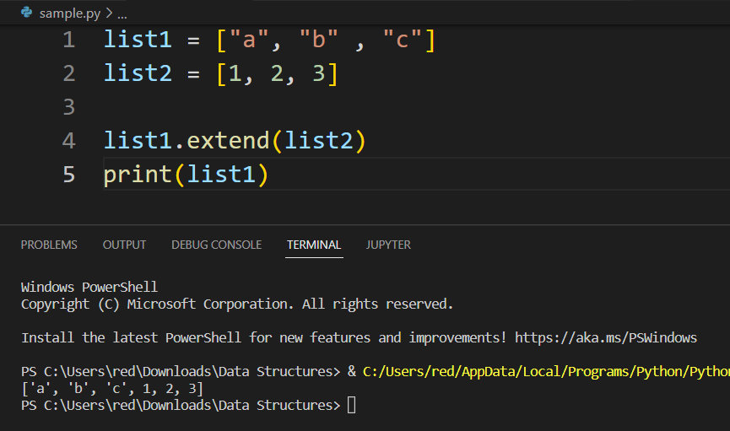

### **Tuples**

Tuples are used to store multiple items in a single variable. Tuple is one of 4 built-in data types in Python used to store collections of data, the other 3 are List, Set, and Dictionary, all with different qualities and usage.

A tuple is a collection which is ordered and unchangeable. Tuples are written with **round brackets**.

**Example:**

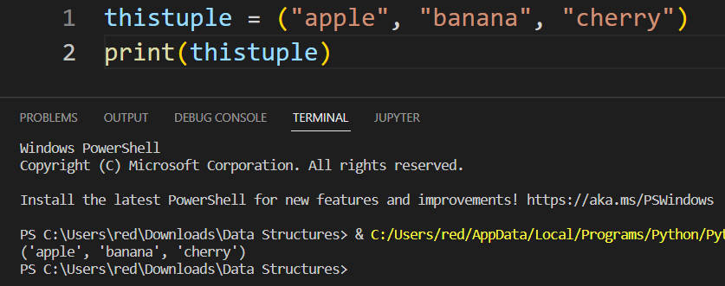

#### Tuple Items

Tuple items are **ordered**, **unchangeable**, and **allow duplicate values**. Tuple items are **indexed**, the first item has index [0], the second item has index [1] etc.

**Ordered**

When we say that tuples are ordered, it means that the items have a defined order, and that order will not change.

**Unchangeable**

Tuples are unchangeable, meaning that we cannot change, add or remove items after the tuple has been created.

**Allow Duplicates**

Since tuples are indexed, they can have items with the same value:

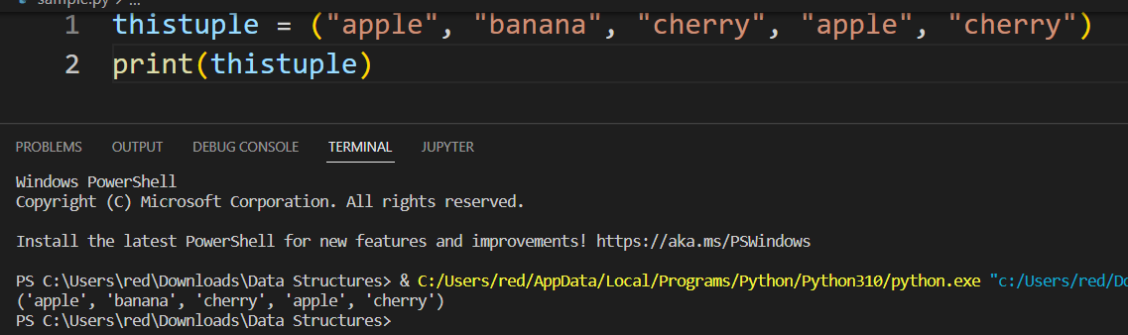

#### Tuple Length

To determine how many items a tuple has, use the **len()** function:

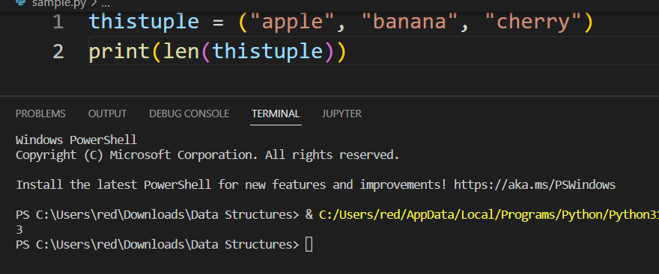

#### Create Tuple with One Item

To create a tuple with only one item, you have to add a comma after the item, otherwise Python will not recognize it as a tuple.

**Example**

One item tuple, remember the comma:

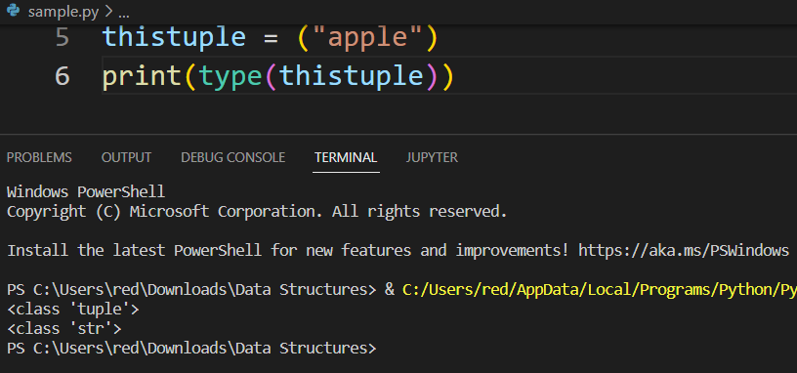

#### Tuple Items Data Types

Tuple items can be of any data type:

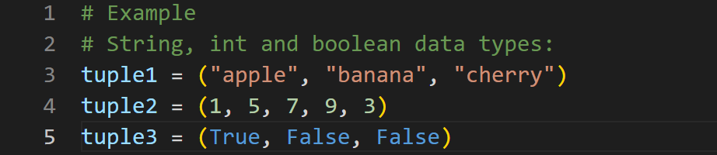

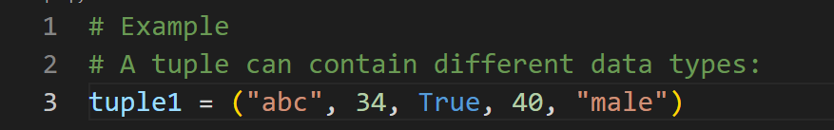

#### The tuple() Constructor

It is also possible to use the tuple() constructor to make a tuple.

Example:

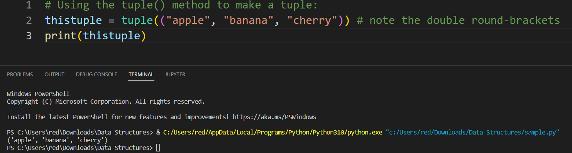

#### Access Tuples

You can access tuple items by referring to the index number, inside square brackets:

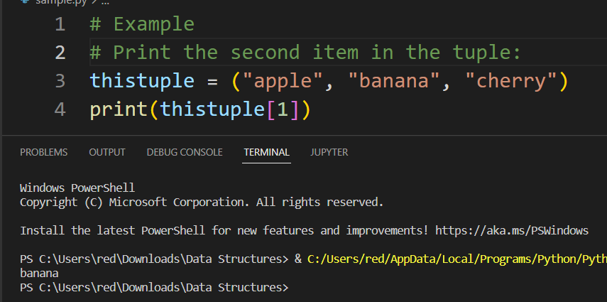

Note: The first item has index 0. Accessing Tuple items is the same as List items by using index number, negative indexing, range indexing and checking item if exist.

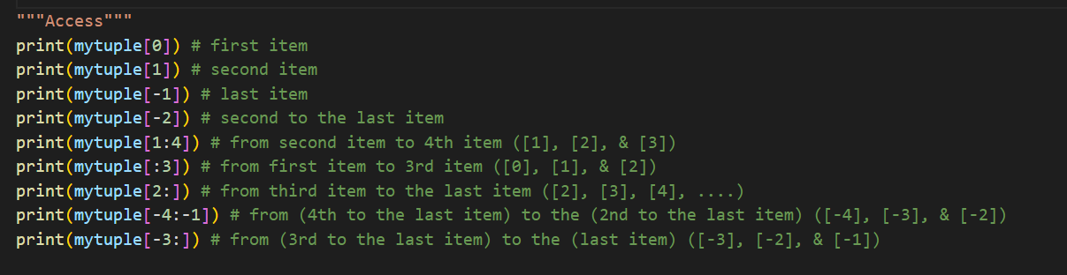

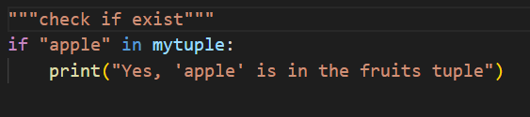

#### Update Tuples

Tuples are unchangeable, meaning that you cannot change, add, or remove items once the tuple is created. But there are some workarounds.

You can convert the tuple into a list, change the list, and convert the list back into a tuple.

Example

Convert the tuple into a list to be able to change it:

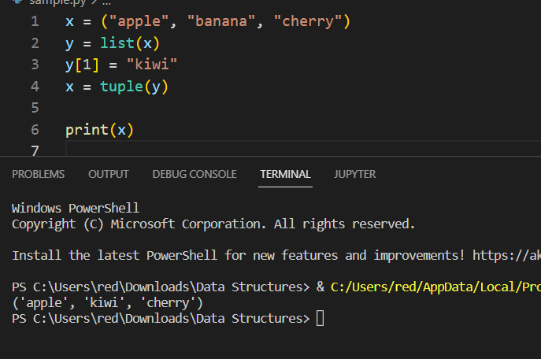

#### Add Items

Since tuples are immutable, they do not have a build-in **append()** method, but there are other ways to add items to a tuple.

1. Convert into a list: Just like the workaround for changing a tuple, you can convert it into a list, add your item(s), and convert it back into a tuple.

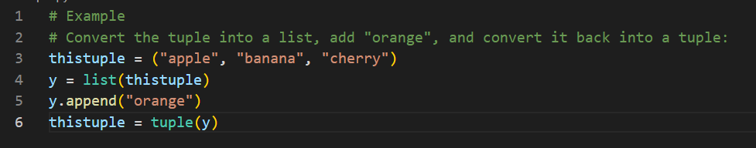

1. Add tuple to a tuple. You are allowed to add tuples to tuples, so if you want to add one item, (or many), create a new tuple with the item(s), and add it to the existing tuple:

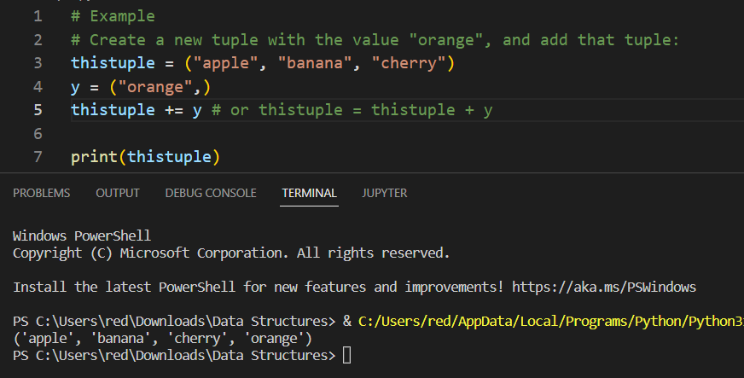

#### Remove Items

Tuples are unchangeable, so you cannot remove items from it, but you can use the same workaround as we used for changing and adding tuple items:

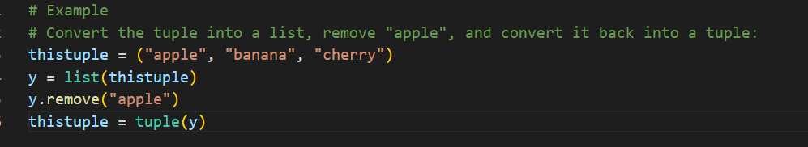

Or you can delete the tuple completely:

The ***del*** keyword can delete the tuple completely:

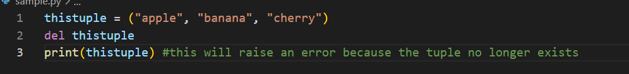

#### Unpack Tuples

When we create a tuple, we normally assign values to it. This is called "packing" a tuple. But, in Python, we are also allowed to extract the values back into variables. This is called "unpacking":

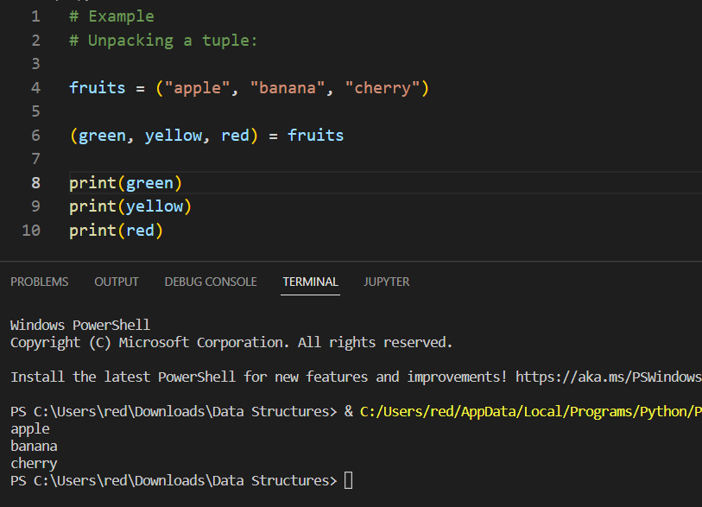

Note: The number of variables must match the number of values in the tuple, if not, you must use an asterisk to collect the remaining values as a list.

##### Using Asterisk*

If the number of variables is less than the number of values, you can add an * to the variable name and the values will be assigned to the variable as a list:

Example

Assign the rest of the values as a list called "red":

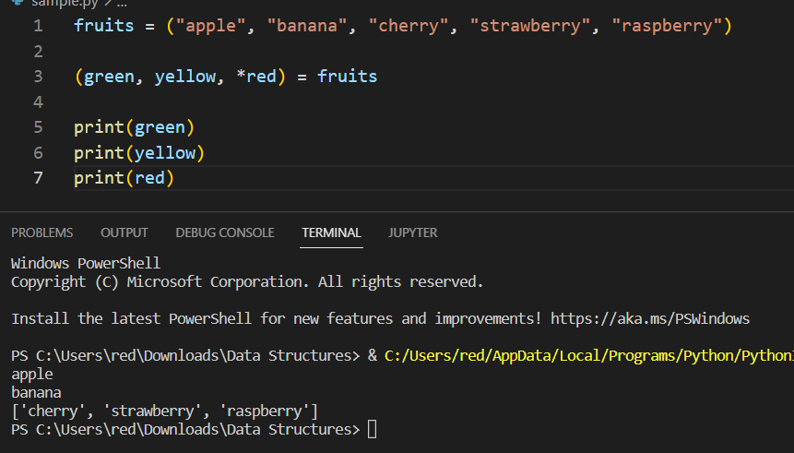

If the asterisk is added to another variable name than the last, Python will assign values to the variable until the number of values left matches the number of variables left.

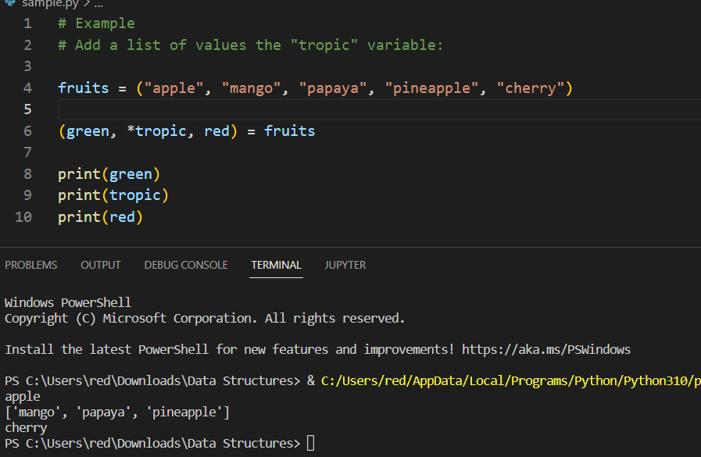

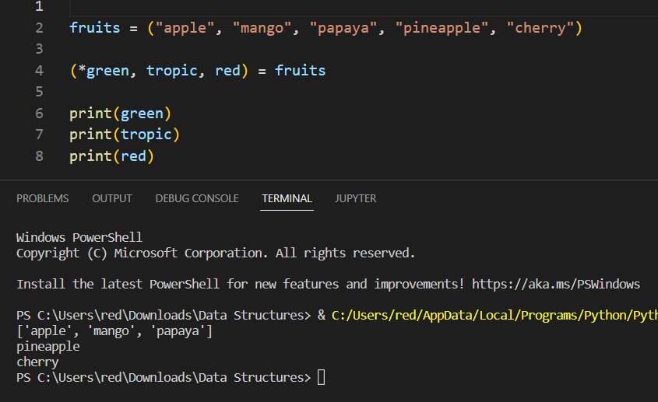

#### Loop Tuples

##### For Loop

You can loop through the tuple items by using a ***for*** loop.

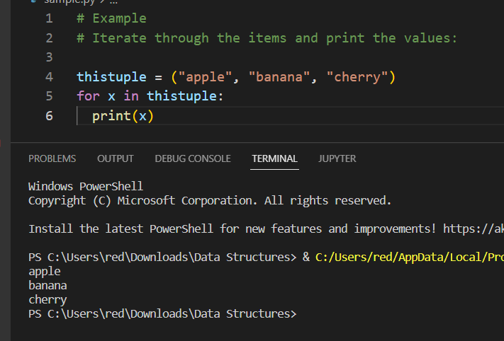

##### Loop Through the Index Numbers

You can also loop through the tuple items by referring to their index number. Use the ***range()*** and ***len()*** functions to create a suitable iterable.

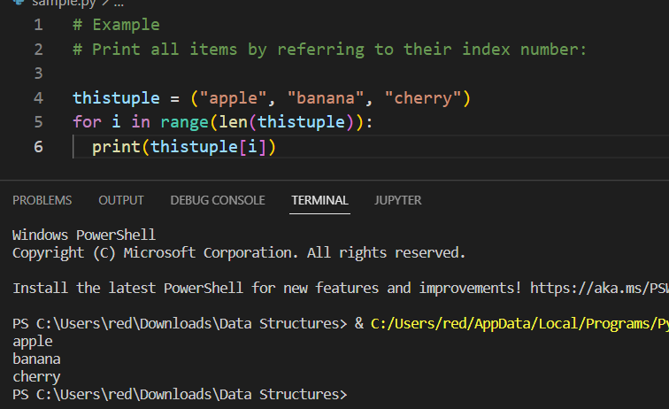

Using While Loop

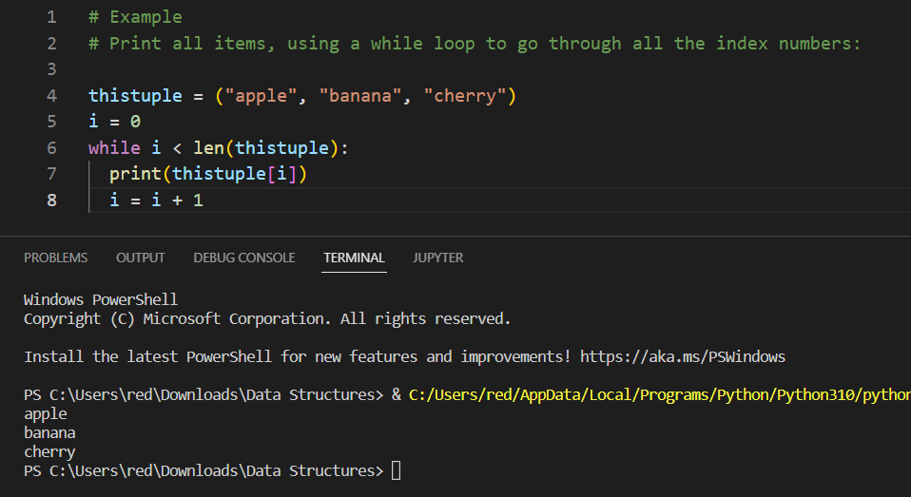

#### Join Tuples

To join two or more tuples you can use the **+** operator:

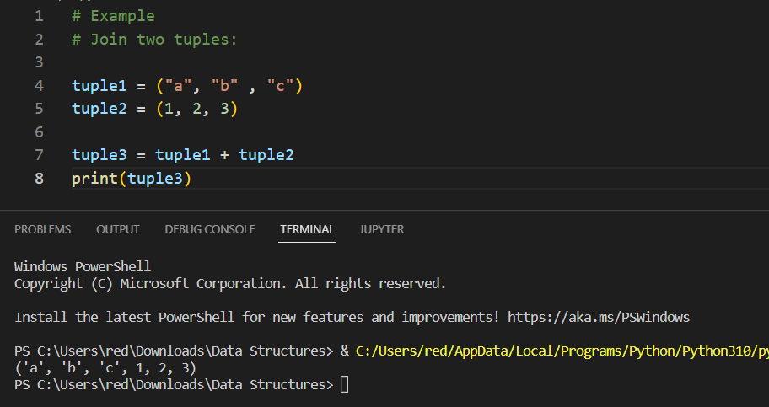

**Multiply Tuples**

If you want to multiply the content of a tuple a given number of times, you can use the * operator:

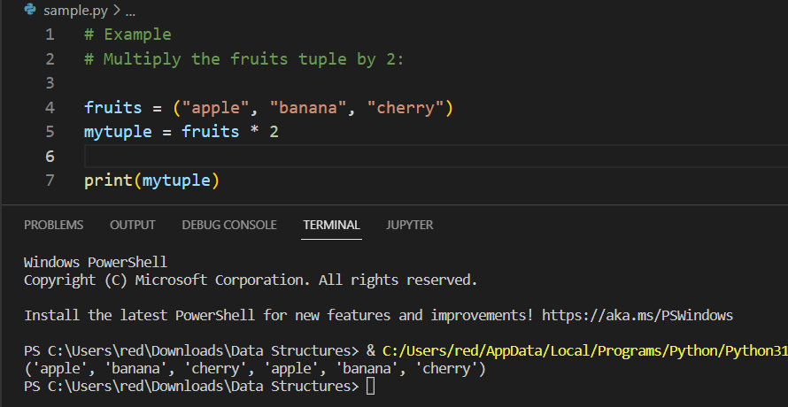

### **Sets**

Sets are used to store multiple items in a single variable. Set is one of 4 built-in data types in Python used to store collections of data, the other 3 are List, Tuple, and Dictionary, all with different qualities and usage.

A set is a collection which is **unordered**, **unchangeable**\*, and **unindexed**.

Note: Set items are unchangeable, but you can remove items and add new items. Sets are written with **curly brackets**.

Example: (this will run 3 times and output order will change because Sets items is unordered)

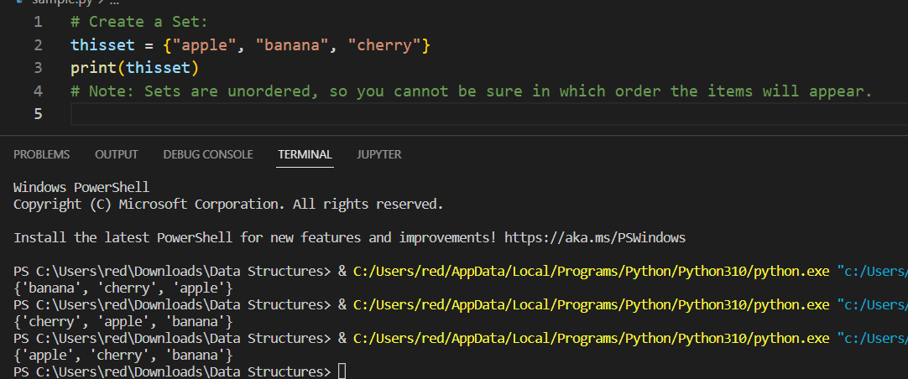

#### Set Items

**Unordered**

Unordered means that the items in a set do not have a defined order. Set items can appear in a different order every time you use them, and cannot be referred to by index or key.

**Unchangeable**

Set items are unchangeable, meaning that we cannot change the items after the set has been created.

Once a set is created, you cannot change its items, but you can remove items and add new items.

**Duplicates not allowed**

Sets cannot have two items with the same value. Duplicate values will be ignored and return only one of duplicated items.

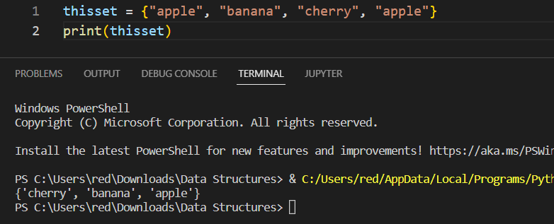

#### Length of a Set

To determine how many items a set has, use the ***len()*** function.

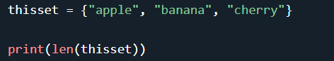

#### Set Items Data Types

Set items can be of any data type:

**Example:** String, int and boolean data types:

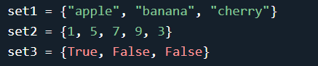

A set can contain different data types:

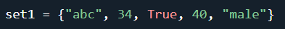

#### The set() Constructor

It is also possible to use the ***set()*** constructor method to make a set.

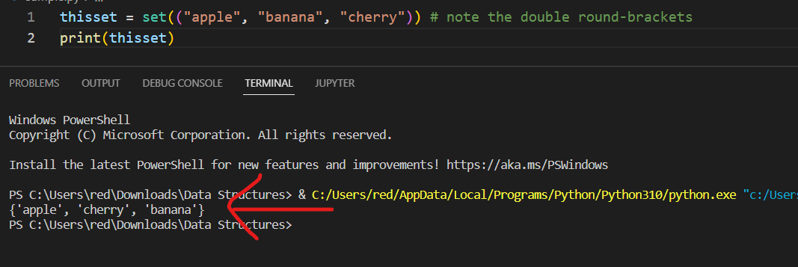

#### Access Set Items

You cannot access items in a set by referring to an index or a key.

But you can loop through the set items using a for loop, or ask if a specified value is present in a set, by using the in keyword.

**Example**

Loop through the set, and print the values:

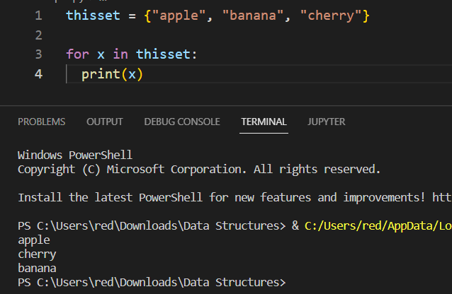

#### Add Set Items

Once a set is created, you cannot change its items, but you can add new items.

To add one item to a set use the ***add()*** method.

**Example**

Add an item to a set, using the ***add()*** method:

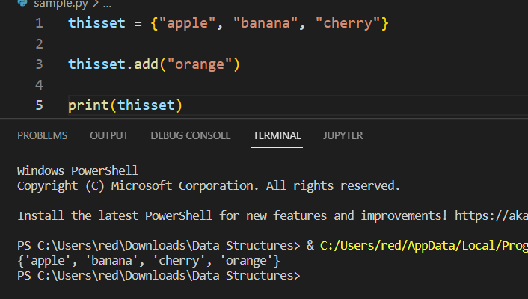

**Add Sets**

To add items from another set into the current set, use the ***update()*** method.

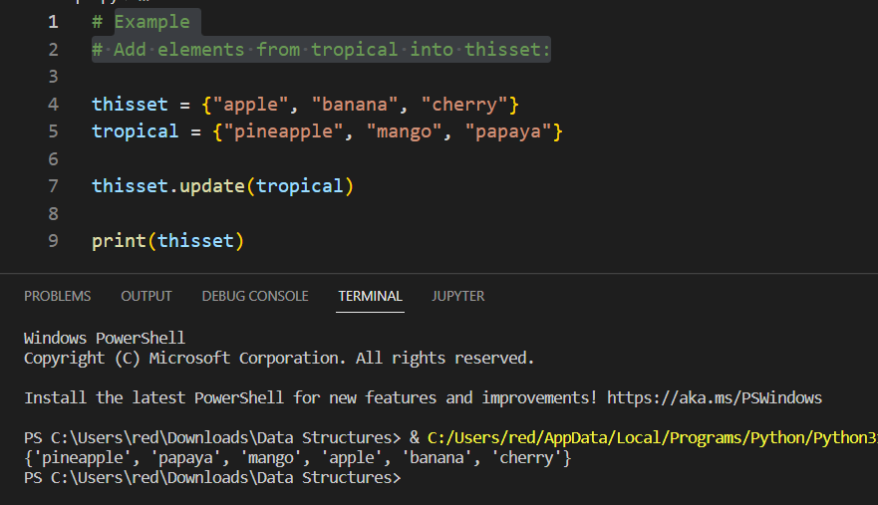

**Add Any Iterable**

The object in the ***update()*** method does not have to be a set, it can be any iterable object (tuples, lists, dictionaries etc.).

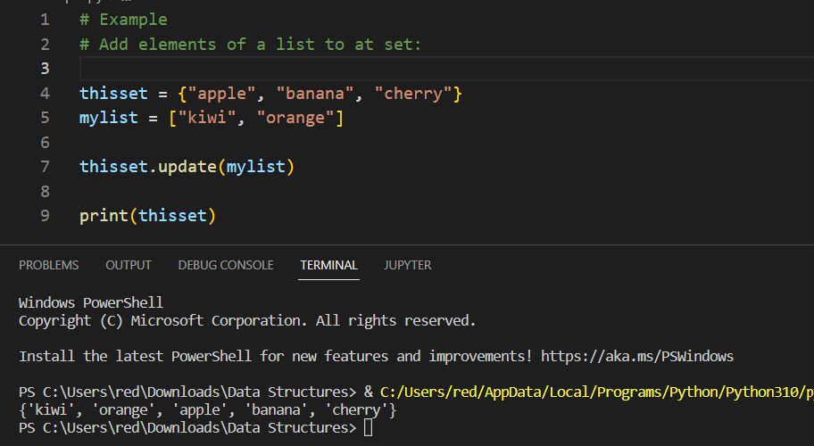

#### Remove Set Items

**Remove Item**

To remove an item in a set, use the ***remove()***, or the ***discard()*** method.

**Example of remove() method:**

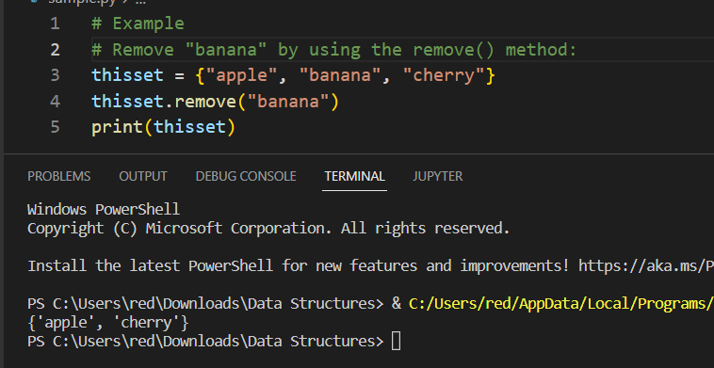

Note: If the item to remove does not exist, **remove()** will raise an **error**.

**Example of discard() method:**

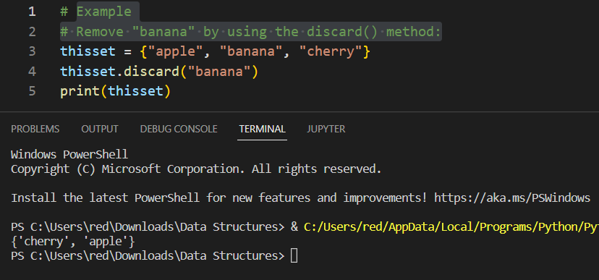

Note: If the item to remove does not exist, **discard()** will **NOT** raise an **error**.

**pop() Method**

You can also use the ***pop()*** method to remove an item in a set, but this method will remove the last item. Remember that sets are unordered, so you will not know what item that gets removed.

The return value of the ***pop()*** method is the removed item.

**Example (**Remove the last item by using the pop() method):

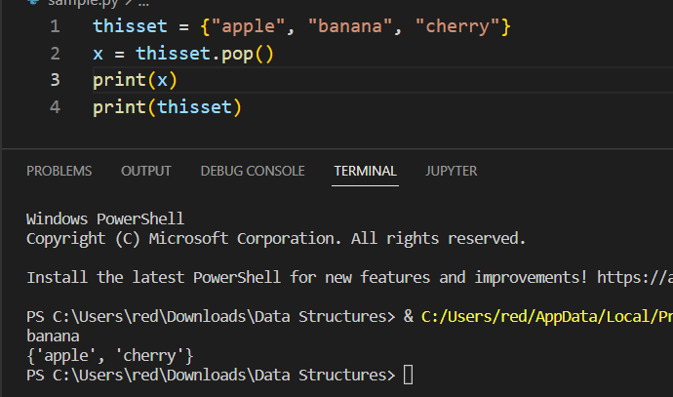

Note: Sets are unordered, so when using the pop() method, you do not know which item that gets removed.

**clear() Method**

The **clear()** method empties the set:

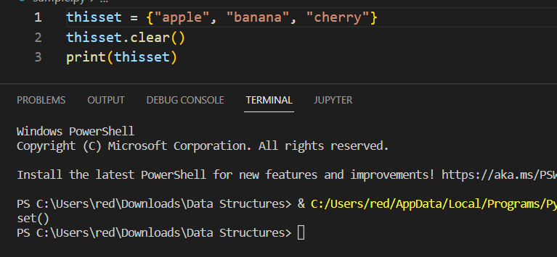

**del Keyword**

**Example:**

The ***del*** keyword will delete the set completely:

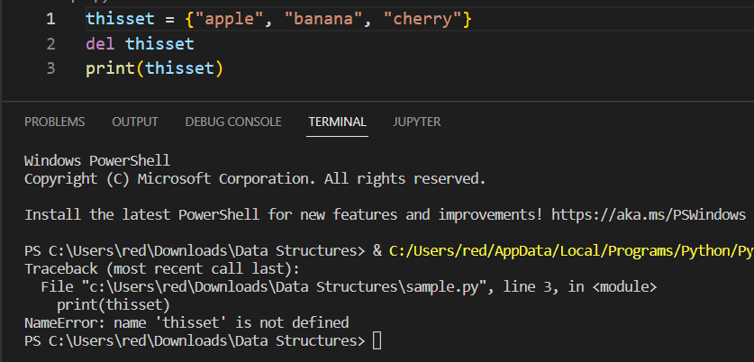

#### Loop Sets

**Loop Items**

You can loop through the set items by using a ***for*** loop:

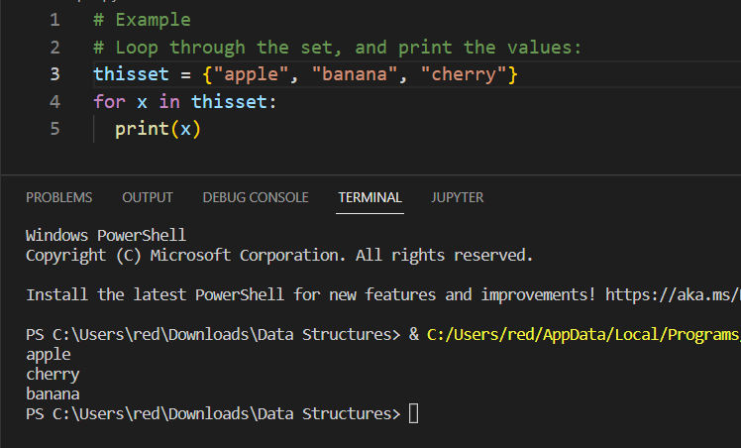

#### Join Sets

**Join Two Sets**

There are several ways to join two or more sets in Python. You can use the ***union()*** method that returns a new set containing all items from both sets, or the ***update()*** method that inserts all the items from one set into another:

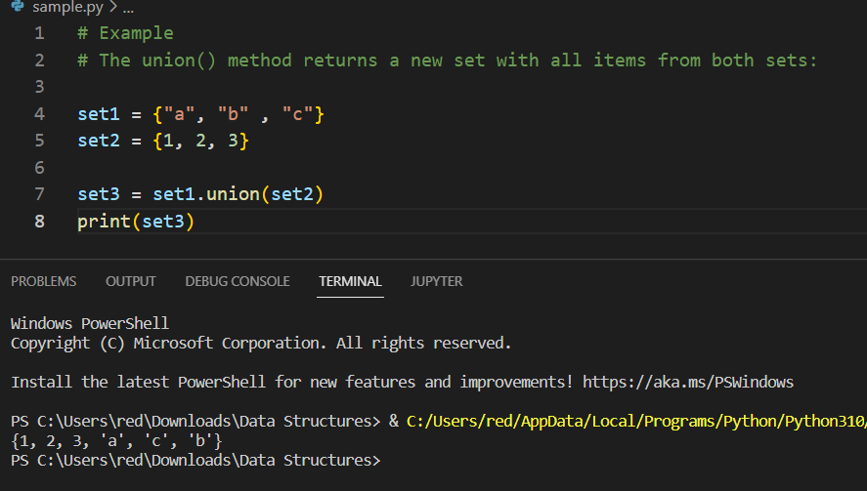

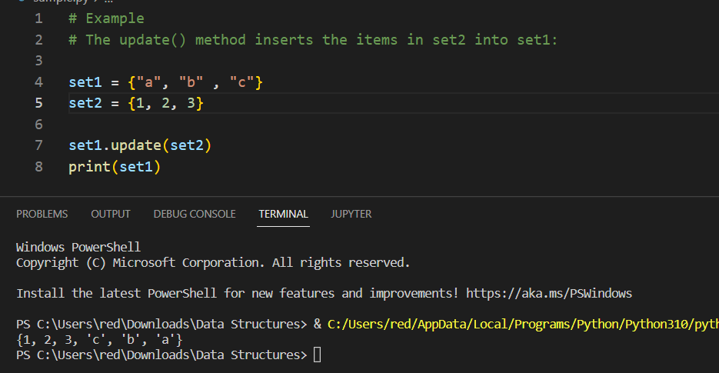

Note: Both **union()** and **update()** will exclude any duplicate items.

### **Dictionary**

Dictionaries are used to store data values in ***key:value*** pairs.

A dictionary is a collection which is **ordered**\*, **changeable** and **do not allow duplicates**. As of Python version 3.7, dictionaries are ordered. In Python 3.6 and earlier, dictionaries are unordered.

Dictionaries are written with **curly brackets**, and have **keys** and **values**:

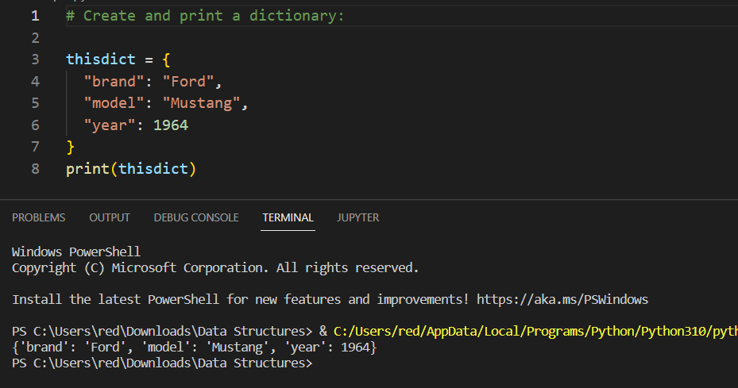

#### Dictionary Items

Dictionary items are **ordered**, **changeable**, and **does not allow duplicates**. Dictionary items are presented in **key**:**value** pairs, and can be referred to by using the **key name**.

**Ordered or Unordered?**

As of Python version 3.7, dictionaries are ordered. In Python 3.6 and earlier, dictionaries are unordered. When we say that dictionaries are ordered, it means that the items have a defined order, and that order will not change. Unordered means that the items does not have a defined order, you cannot refer to an item by using an index.

**Changeable**

Dictionaries are changeable, meaning that we can change, add or remove items after the dictionary has been created.

**Duplicates Not Allowed**

Dictionaries cannot have two items with the same key:

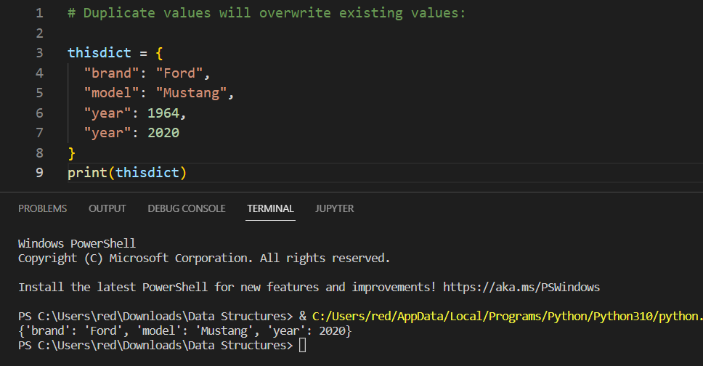

#### Dictionary Length

To determine how many items a dictionary has, use the **len()** function:

Print the number of items in the dictionary:

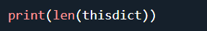

#### Dictionary Data Types

The values in dictionary items can be of any data type:

Example: String, int, boolean, and list data types:

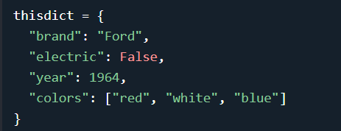

#### Access Items

You can access the items of a dictionary by referring to its ***key name***, inside square brackets:

Get the value of the "model" key:

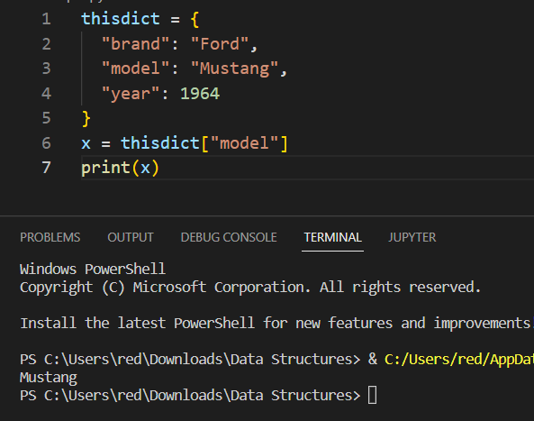

There is also a method called **get()** that will give you the same result:

Get the value of the "model" key:

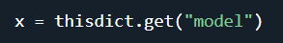

##### Get Keys

The **keys()** method will return a list of all the keys in the dictionary.

Get a list of the keys:

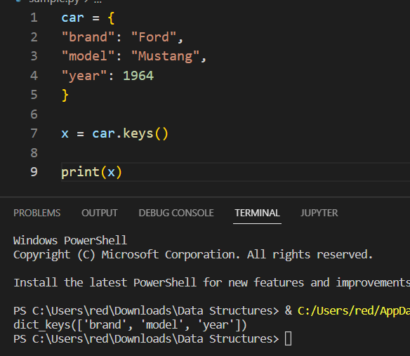

##### Get Values

The **values()** method will return a list of all the values in the dictionary.

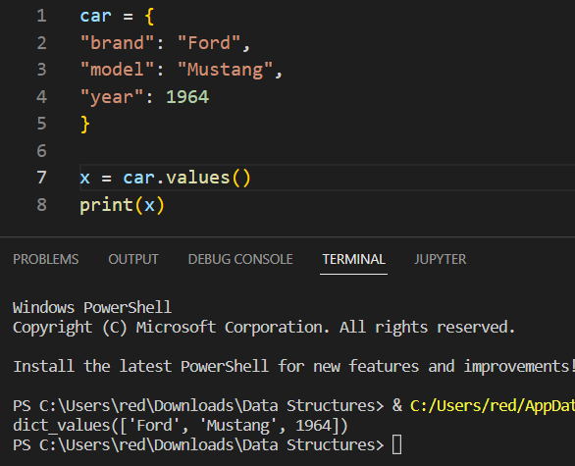

##### Get Items

The **items()** method will return each item in a dictionary, as tuples in a list.

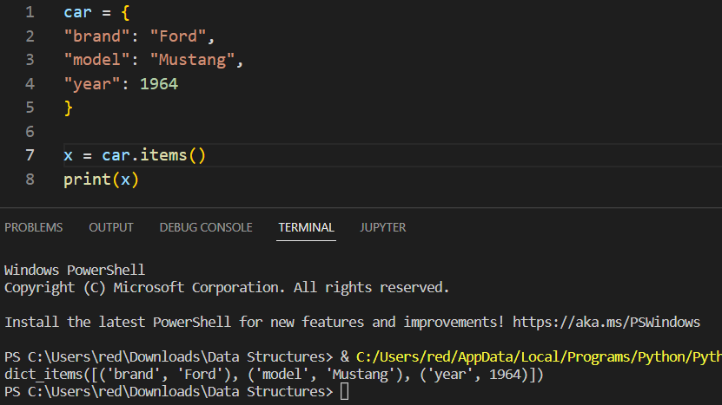

##### Check if Key Exists

To determine if a specified key is present in a dictionary use the in keyword:

Check if "model" is present in the dictionary:

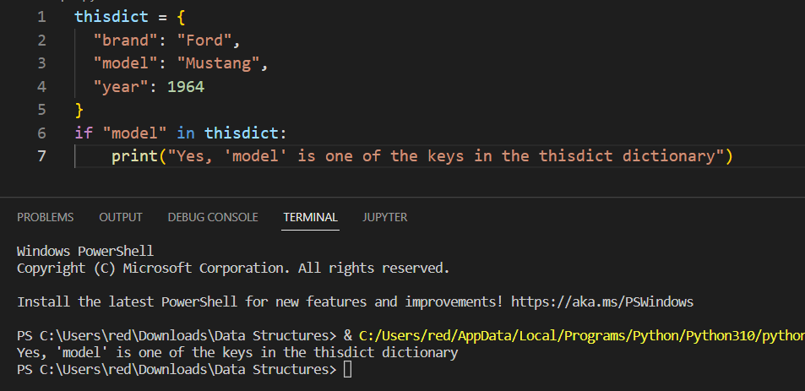

#### Change Items

You can change the ***value*** of a specific item by referring to its ***key name***:

**Example**

Change the "year" to 2018:

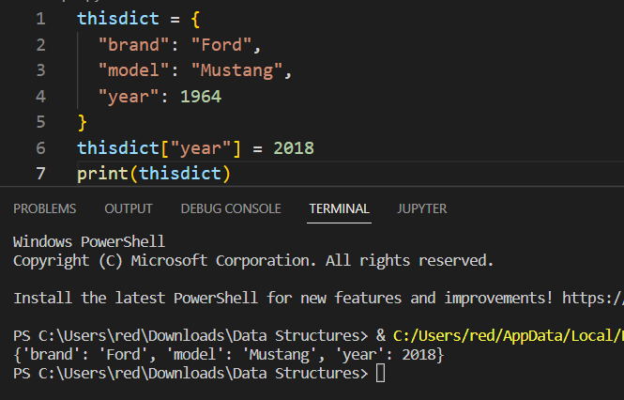

##### update() method

The **update()** method will update the dictionary with the items from the given argument. The argument must be a **dictionary**, or an **iterable** object with **key:value** pairs.

Example: Update the "year" of the car by using the ***update()*** method:

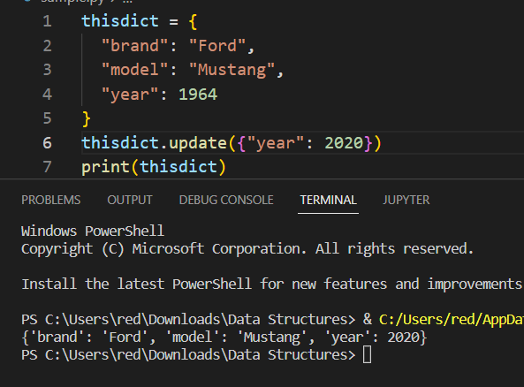

#### Add Items

Adding an item to the dictionary is done by using a new **index** **key** and assigning a **value** to it:

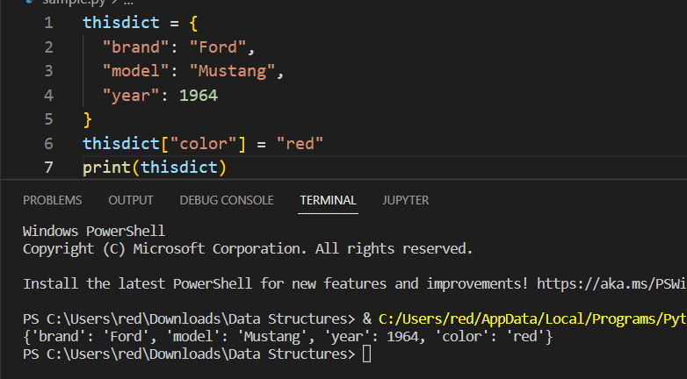

Using **update()** method.

An index name or key name that not exist in the dictionary, will be added as new item.

Add a color item to the dictionary by using the **update()** method:

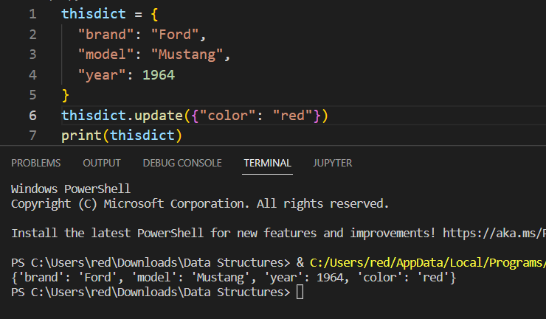

#### Remove Items

There are several methods to remove items from a dictionary:

##### pop() method

The **pop()** method removes the item with the specified **key name**:

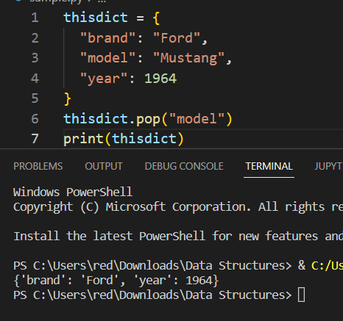

##### popitem() method

The **popitem()** method removes the **last** inserted item (in versions before 3.7, a random item is removed instead):

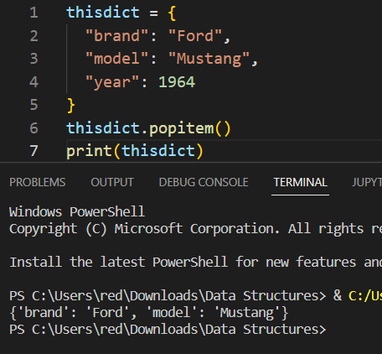

##### del keyword

The ***del*** keyword removes the item with the specified ***key name***:

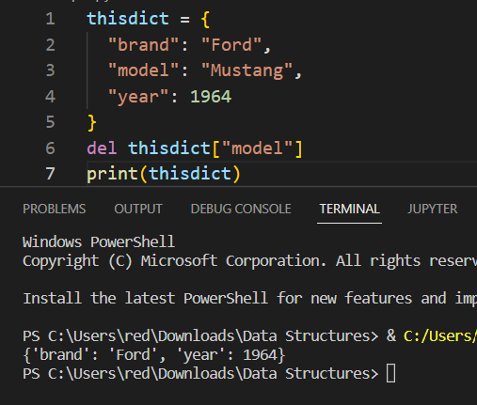

The **del** keyword can also delete the dictionary completely:

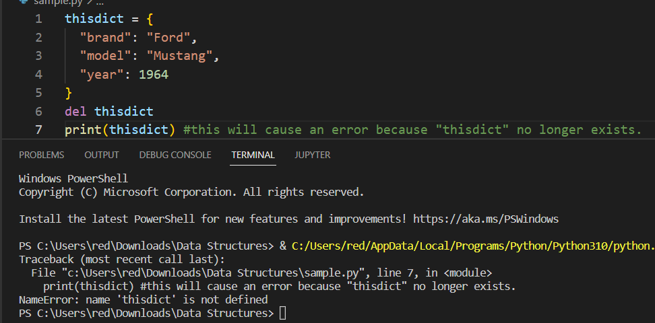

##### clear() method

The **clear()** method empties the dictionary:

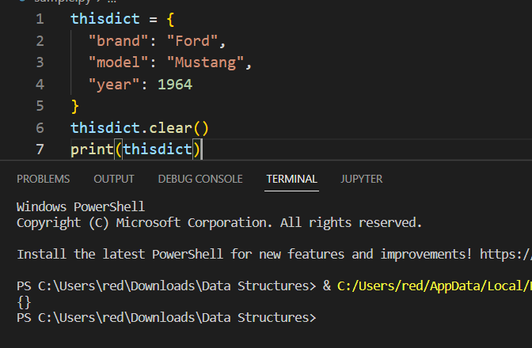

#### Loop Dictionaries

You can loop through a dictionary by using a for loop.

When looping through a dictionary, the return value are the **keys** of the dictionary, but there are methods to return the **values** as well.

**Example:**

Print all key names in the dictionary, one by one:

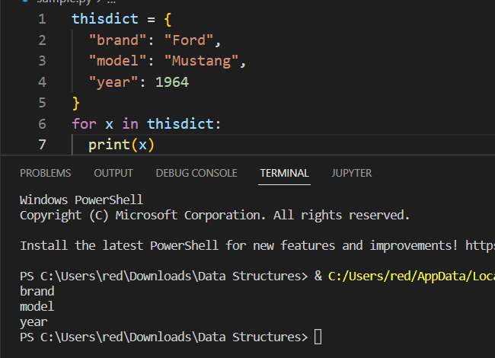

Print all values in the dictionary, one by one:

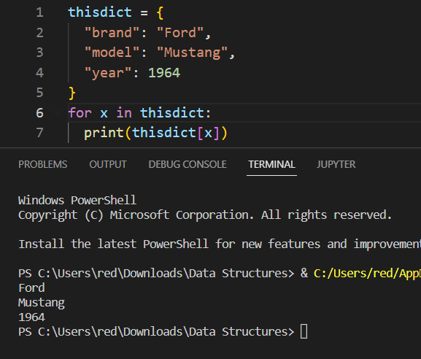

You can also use the **values()** method to return **values** of a dictionary:

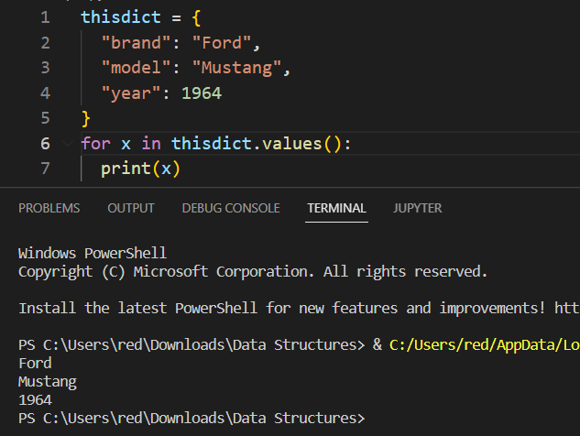

You can use the **keys()** method to return the keys of a dictionary:

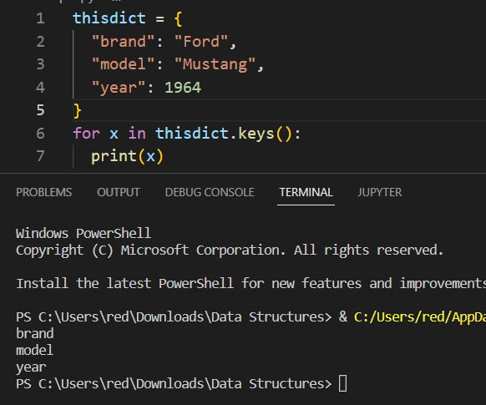

Loop through **both keys and values**, by using the **items()** method:

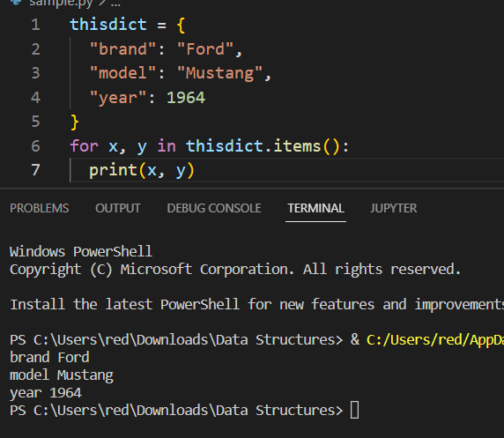

#### Copy Dictionaries

There are ways to make a copy, one way is to use the built-in Dictionary method copy().

Make a copy of a dictionary with the **copy()** method:

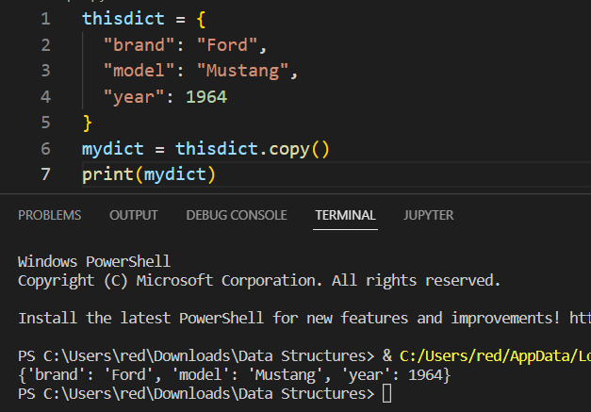

Another way to make a copy is to use the built-in function **dict().**

Make a copy of a dictionary with the **dict()** function:

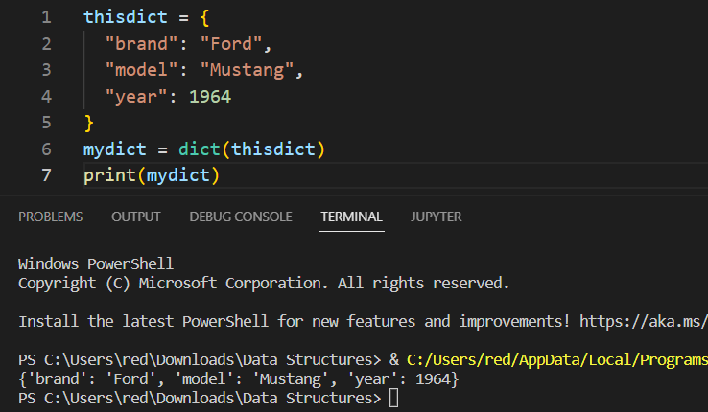

#### Nested Dictionaries

A dictionary can contain dictionaries, this is called nested dictionaries.

**Example**

Create a dictionary that contain three dictionaries:

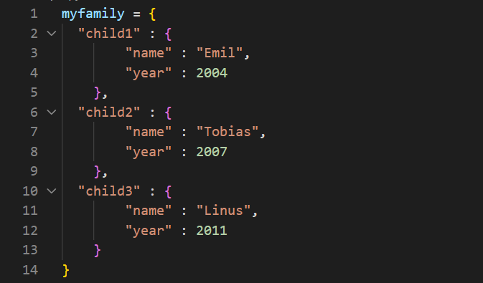

Or, if you want to add three dictionaries into a new dictionary:

Create three dictionaries, then create one dictionary that will contain the other three dictionaries:

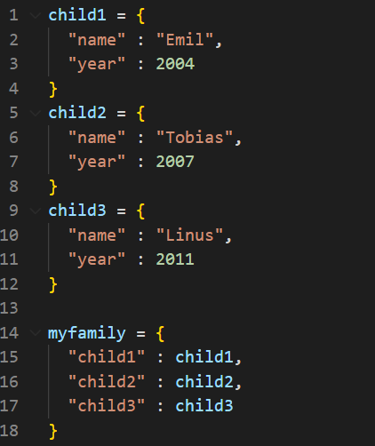

# Functions

A function is a block of code which only runs when it is called. You can pass data, known as parameters, into a function. A function can return data as a result.

Functions are units which perform a particular task, take some input, and which may give some output. One of the most obvious advantages is the division of a program into smaller parts.

**The advantages of dividing the program into functions**

* **Modular Programming - I**f a program is divided into small parts in such a way that different parts each perform some specific task, then each part can be called as per the requirement.
* **Reusability of Code -** A function can be called many times. This spares the programmer from the horror of rewriting the same code again, which in turn can reduce the length of the program.
* **Manageability -** Dividing a bigger task into smaller functions makes the program manageable. It becomes easy to locate bugs and therefore make the program reliable. It also becomes easy to carry out local optimization in a function.

**DEFINITION AND INVOCATION**



**The definition of a function contains the following:**

* Name of a function: The name of a function is any valid identifier. It should be noted though that the name of a function should be meaningful and, if possible, convey the task to be performed by the function.
* Parameter: The list of parameters (separated by commas) is given in the parentheses following the name of the function. The parameters are basically the input to the function. A function may have any parameters.
* Body of the function: The body of the function contains the code that implements the task to be performed by the function.

**SYNTAX:**



## Creating a Function

In Python a function is defined using the ***def*** keyword:

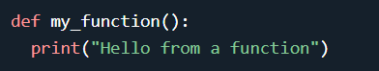

## Calling a Function

To call a function, use the function name followed by parenthesis:

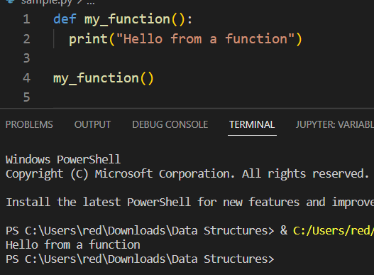

## Parameter and Argument

### Arguments

Information can be passed into functions as arguments.

Arguments are specified after the function name, inside the parentheses. You can add as many arguments as you want, just separate them with a comma.

The following example has a function with one argument (fname). When the function is called, we pass along a first name, which is used inside the function to print the full name:

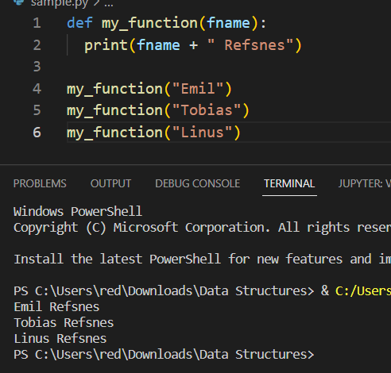

Arguments are often shortened to **args** in Python documentations.

### **Parameters or Arguments?**

The terms ***parameter*** and ***argument*** can be used for the same thing: information that are passed into a function.

From a function's perspective: A **parameter** is the **variable** listed **inside** the **parentheses** in the **function** **definition**. An **argument** is the **value** that is **sent** to the **function** when it is **called**.

## Number of Arguments

By default, a function must be called with the correct number of arguments. Meaning that if your function expects 2 arguments, you have to call the function with 2 arguments, not more, and not less.

**Example**

This function expects 2 arguments, and gets 2 arguments:

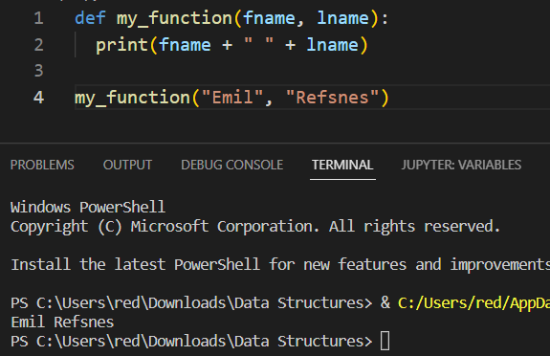

If you try to call the function with 1 or 3 arguments, you will get an error:

This function expects 2 arguments, but gets only 1:

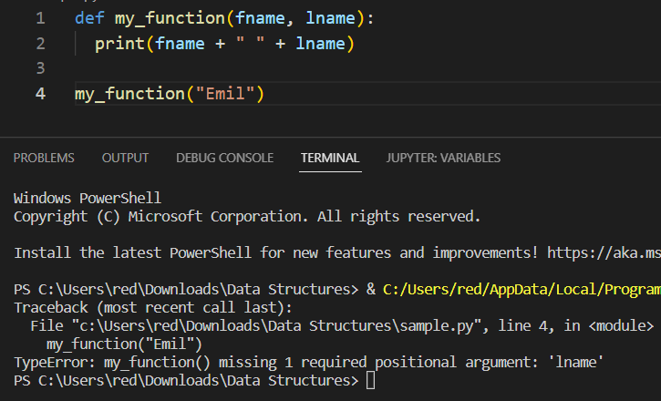

## *args

Arbitrary Arguments, *args

If you do not know how many arguments that will be passed into your function, add a **\*** before the parameter name in the function definition.

This way the function will receive a tuple of arguments, and can access the items accordingly:

**Example**

If the number of arguments is unknown, add a **\*** before the parameter name:

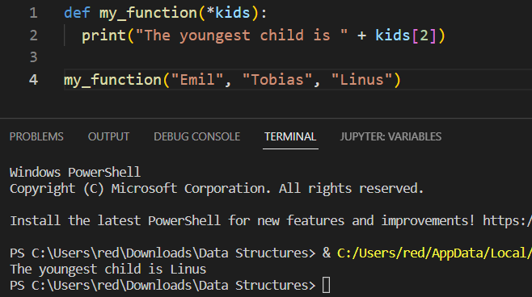

Arbitrary Arguments are often shortened to *args in Python documentations.

## Keyword arguments

You can also send arguments with the ***key = value*** syntax. This way the order of the arguments does not matter.

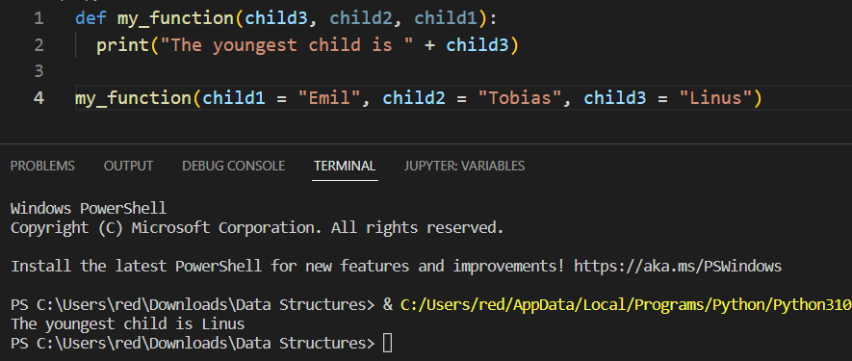

The phrase Keyword Arguments are often shortened to **kwargs** in Python documentations.

## **kwargs

Arbitrary Keyword Arguments, **kwargs

If you do not know how many keyword arguments that will be passed into your function, add two asterisk: **\*\*** before the parameter name in the function definition.

This way the function will receive a dictionary of arguments, and can access the items accordingly:

**Example**:

If the number of keyword arguments is unknown, add a double ** before the parameter name:

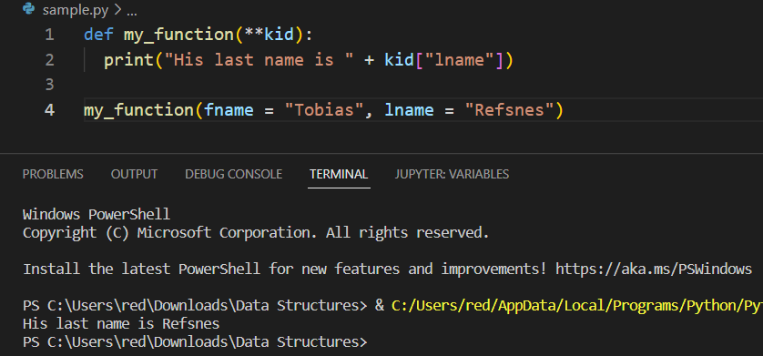

Arbitrary Keyword Arguments are often shortened to **\*\*kwargs** in Python documentations.

## Variable parameter list

## Optional parameter / default parameter value

Default Parameter Value

The following example shows how to use a default parameter value. If we call the function without argument, it uses the default value:

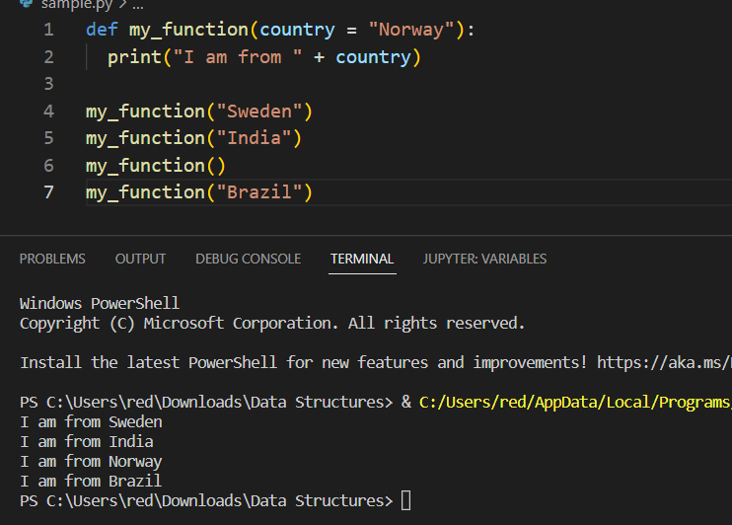

## Passing a List as an argument

You can send any data types of argument to a function (string, number, list, dictionary etc.), and it will be treated as the same data type inside the function.

E.g. if you send a List as an argument, it will still be a List when it reaches the function:

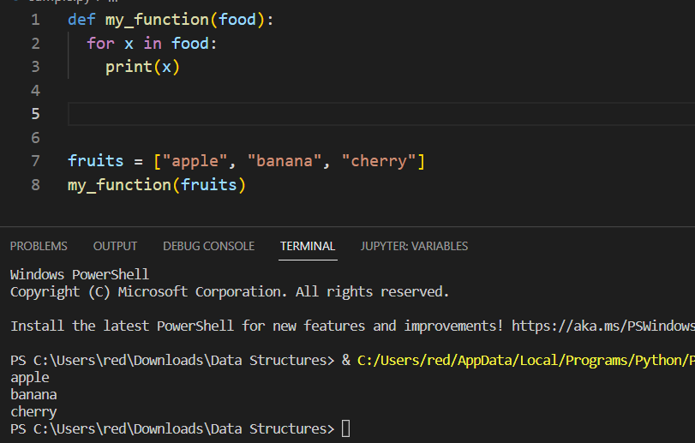

## Function return value and Function Return type

To let a function return a value, use the ***return*** statement:

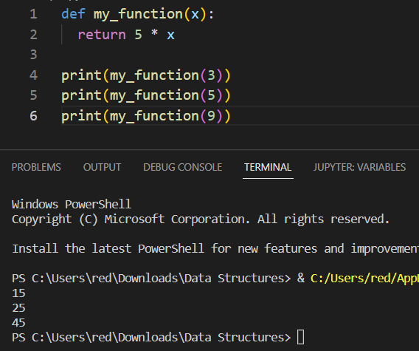

## Pass statement in functions

***function*** definitions cannot be empty, but if you for some reason have a function definition with no content, put in the pass statement to avoid getting an error.

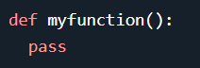

## Recursive functions

Python also accepts **function recursion**, which means a **defined** **function** can **call itself**.

Recursion is a common mathematical and programming concept. It means that a function calls itself. This has the benefit of meaning that you can loop through data to reach a result.

The developer should be very careful with recursion as it can be quite easy to slip into writing a function which never terminates, or one that uses excess amounts of memory or processor power. However, when written correctly recursion can be a very efficient and mathematically-elegant approach to programming.

In this example, ***tri_recursion()*** is a function that we have defined to call itself ("recurse"). We use the ***k*** variable as the data, which decrements (***-1***) every time we recurse. The recursion ends when the condition is not greater than 0 (i.e. when it is 0).

To a new developer it can take some time to work out how exactly this works, best way to find out is by testing and modifying it.

**Recursion Example**

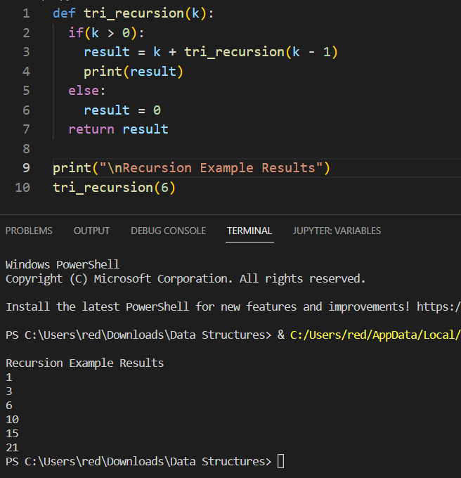

## String Functions

Python has a set of built-in methods that you can use on strings.

**String capitalize() Method**

Upper case the first letter in this sentence:

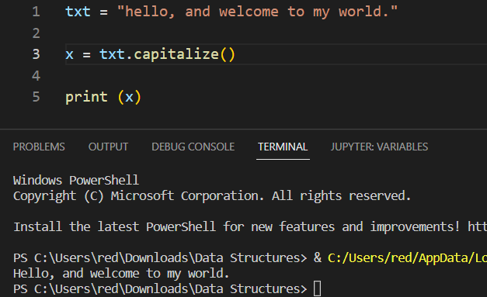

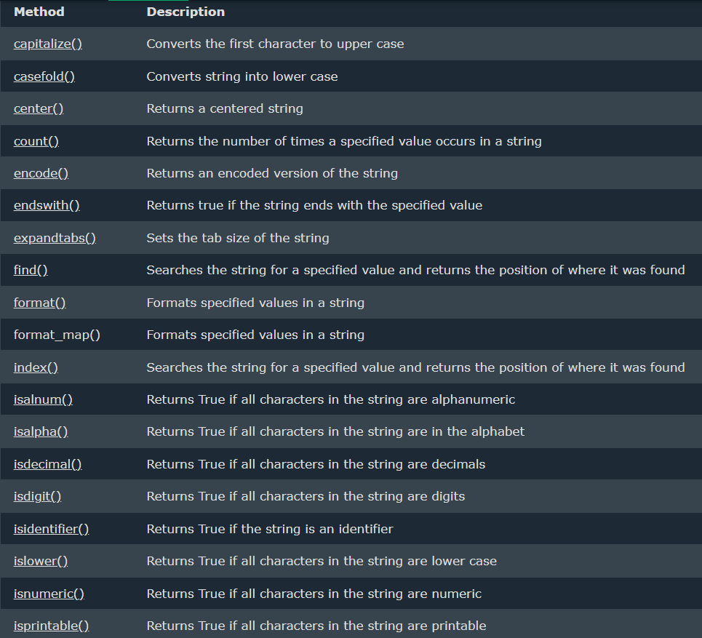

For other functions: <https://www.w3schools.com/python/python_strings_methods.asp>

## Other built-in functions

Python has a set of built-in functions.

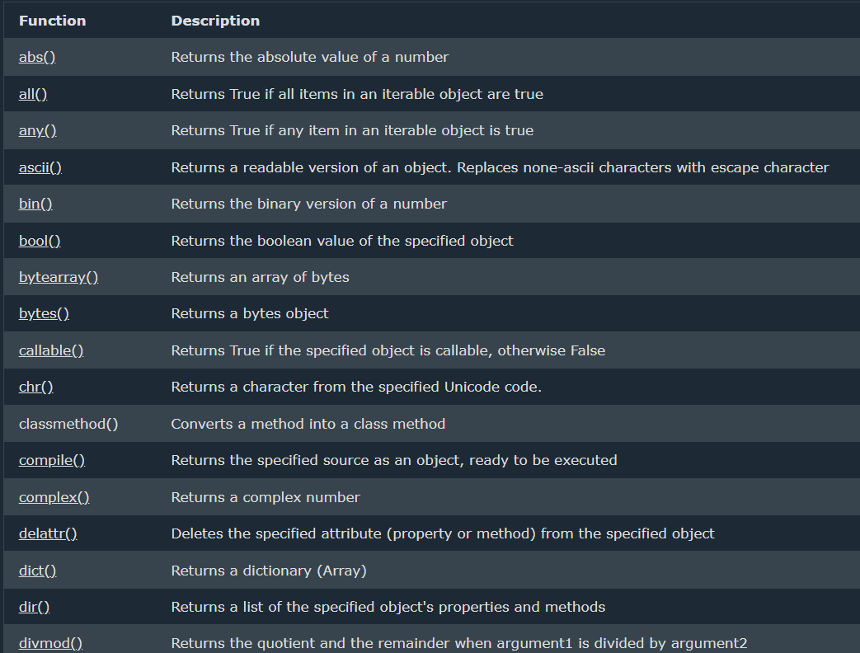

For other built-in function in python: <https://www.w3schools.com/python/python_ref_functions.asp>

## Higher order functions

A function is called **Higher Order Function** if it contains other functions as a parameter or returns a function as an output i.e, the functions that operate with another function are known as Higher order Functions. It is worth knowing that this higher order function is applicable for functions and methods as well that takes functions as a parameter or returns a function as a result. Python too supports the concepts of higher order functions.

**Properties of higher-order functions:**

* A function is an instance of the Object type.
* You can store the function in a variable.
* You can pass the function as a parameter to another function.
* You can return the function from a function.
* You can store them in data structures such as hash tables, lists, …

### **Functions as objects**

In Python, a function can be assigned to a variable. This assignment does not call the function, instead a reference to that function is created. Consider the below example, for better understanding.

**Example:**

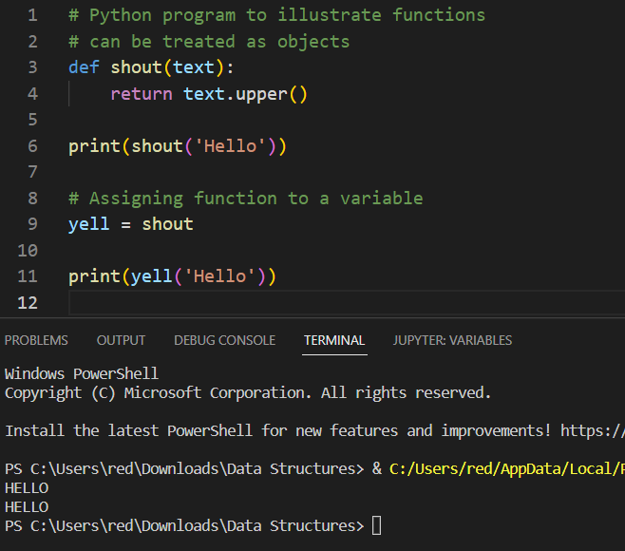

In the above example, a function object referenced by shout and creates a second name pointing to it, yell.

### **Passing Function as an argument to other function**

Functions are like objects in Python, therefore, they can be passed as argument to other functions. Consider the below example, where we have created a function greet which takes a function as an argument.

**Example:**

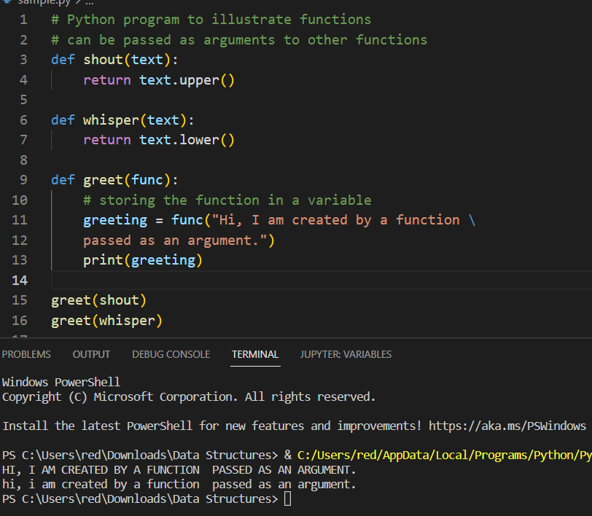

### **Returning function**

As functions are objects, we can also return a function from another function. In the below example, the create_adder function returns adder function.

**Example:**

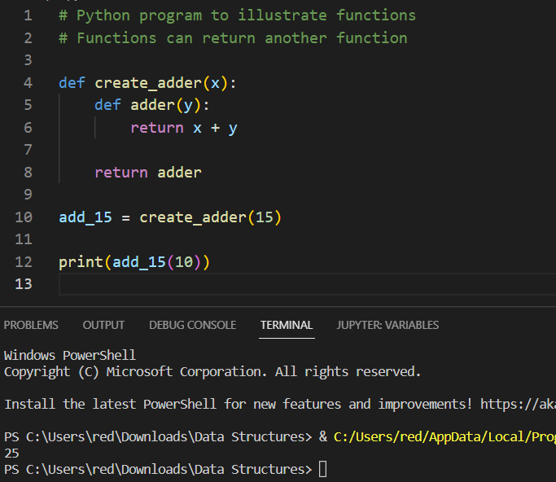

## **Decorators**

Decorators are the most common use of higher-order functions in Python. It allows programmers to modify the behavior of function or class. Decorators allow us to wrap another function in order to extend the behavior of wrapped function, without permanently modifying it. In Decorators, functions are taken as the argument into another function and then called inside the wrapper function.

Syntax:

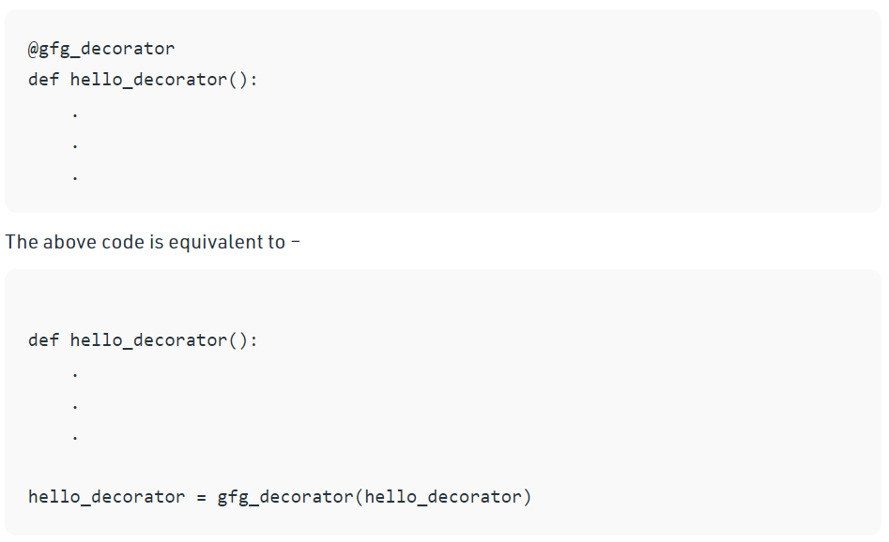

In the above code, ***gfg_decorator*** is a callable function, will add some code on the top of some another callable function, ***hello_decorator*** function and return the wrapper function.

Example:

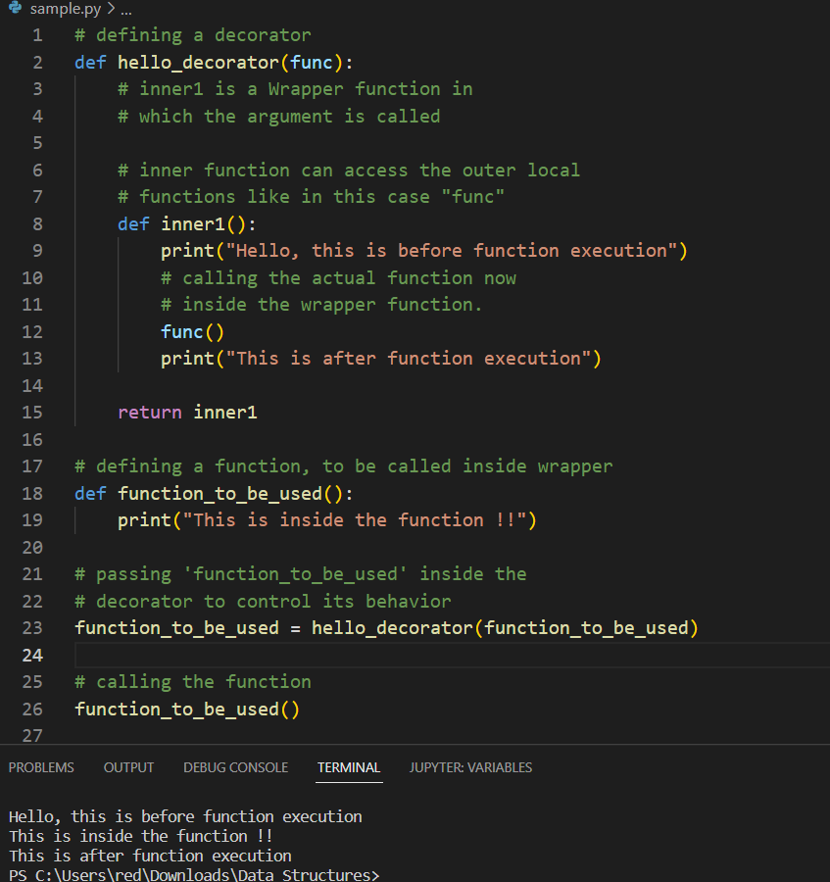

## Lambda

A ***lambda function*** is a small anonymous function.

A ***lambda function*** can take any number of arguments, but can only have one expression.

### **Syntax**

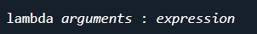

The expression is executed and the result is returned:

**Example**

Add 10 to argument ***a***, and return the result:

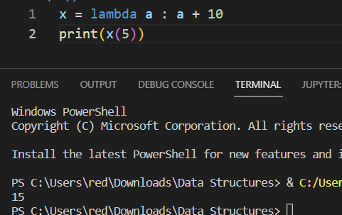

Lambda functions can take any number of arguments:

**Example**

Multiply argument ***a*** with argument ***b*** and return the result:

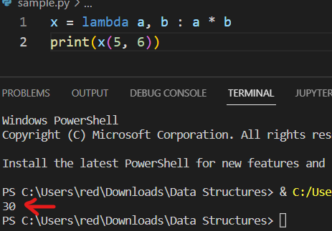

**Example**

Summarize argument ***a***, ***b***, and ***c*** and return the result:

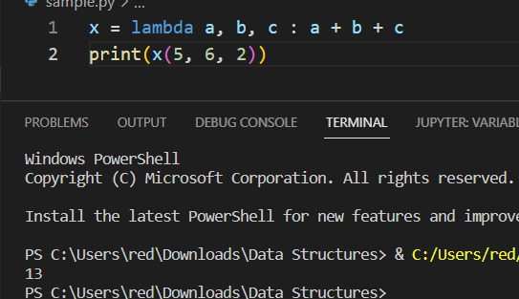

### **Why Use Lambda Functions?**

The power of lambda is better shown when you use them as an anonymous function inside another function.

Say you have a function definition that takes one argument, and that argument will be multiplied with an unknown number:

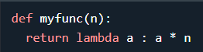

Use that function definition to make a function that always doubles the number you send in:

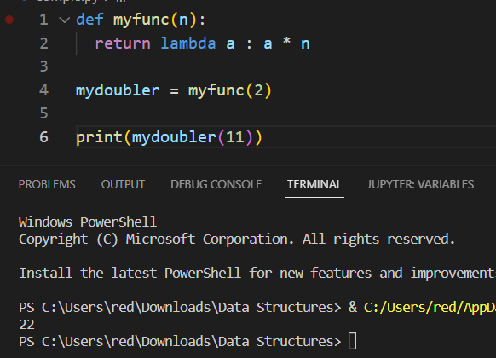

Or, use the same function definition to make a function that always triples the number you send in:

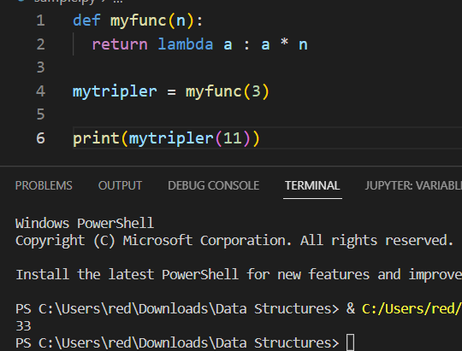

Or, use the same function definition to make both functions, in the same program:

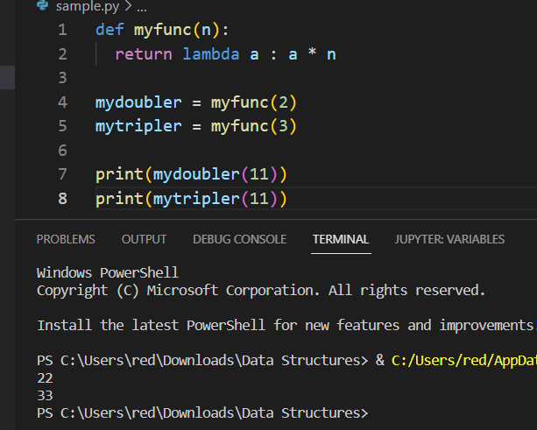

Use lambda functions when an anonymous function is required for a short period of time.

# MODULES

As your program gets longer, you may want to split it into several files for easier maintenance. You may also want to use a handy function that you’ve written in several programs without copying its definition into each program.

To support this, Python has a way to put definitions in a file and use them in a script or in an interactive instance of the interpreter. Such a file is called a *module*; definitions from a module can be *imported* into other modules or into the *main* module

**Module** is a file containing a set of functions you want to include in your application. Python files contains different related functions.

## Create a Module

To create a module just save the code you want in a file with the file extension ***.py***:

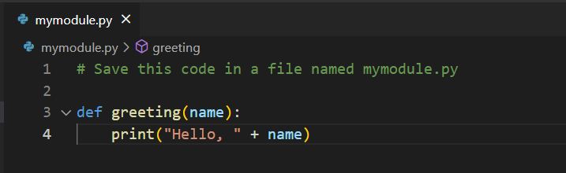

## Use a Module

Now we can use the module we just created, by using the ***import*** statement:

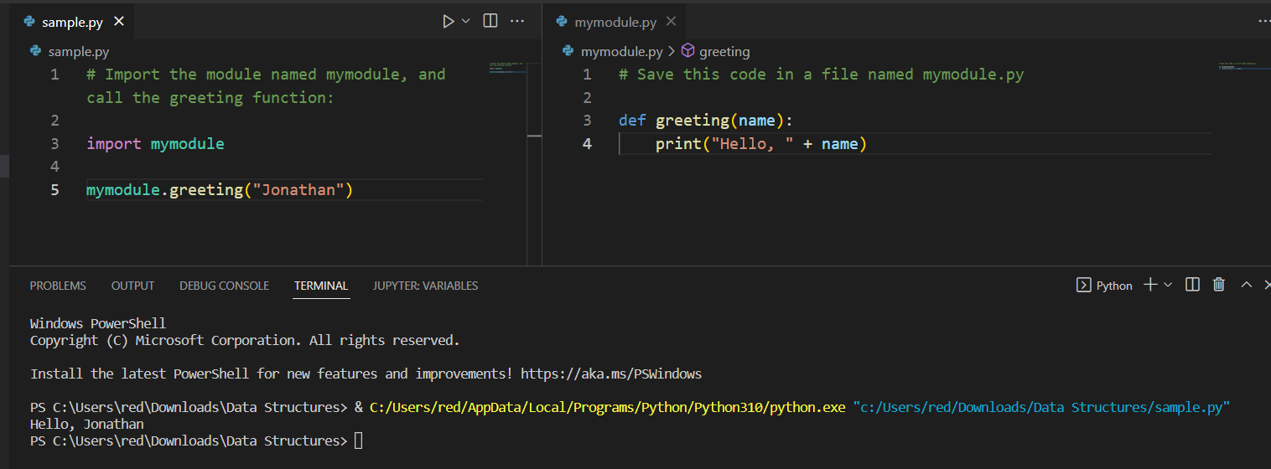

Note: When using a function from a module, use the syntax: **module_name.function_name**.

## Variables in Module

The module can contain functions, as already described, but also variables of all types (arrays, dictionaries, objects etc):

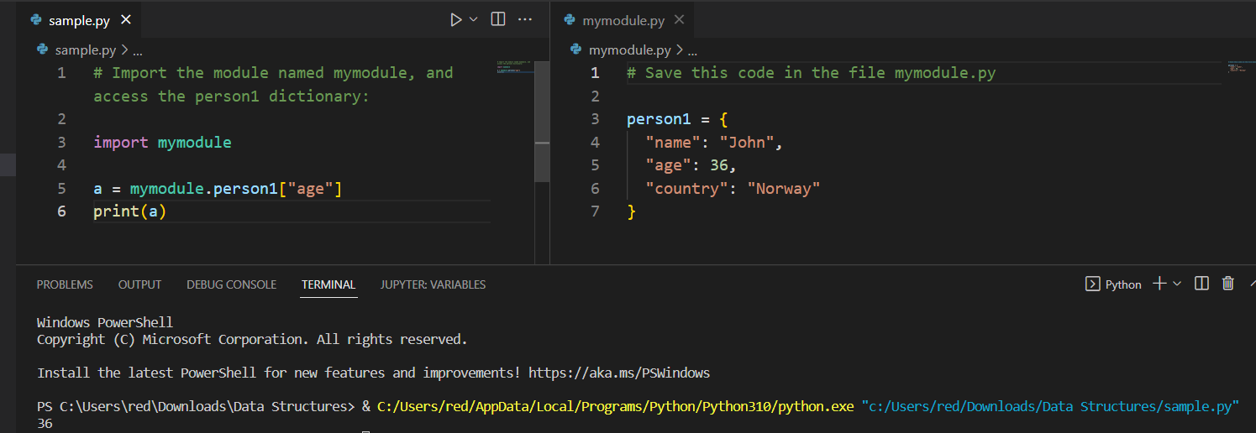

## Naming a Module

You can name the module file whatever you like, but it must have the file extension ***.py***

## Re-naming a Module

You can create an alias when you **import** a module, by using the ***as*** keyword:

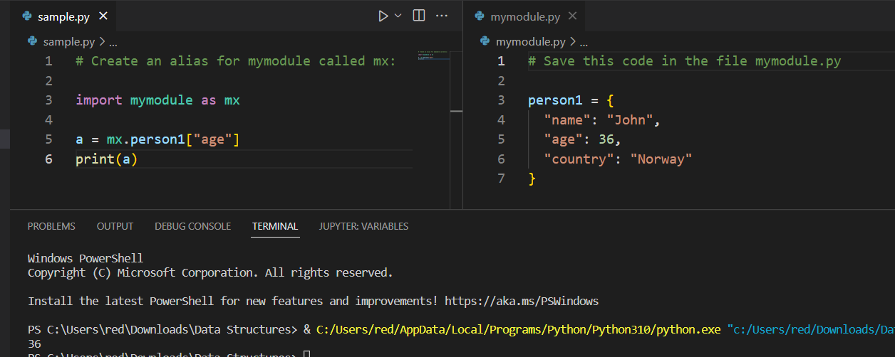

## Built-in Modules

There are several built-in modules in Python, which you can import whenever you like.

**Example**

Import and use the ***platform*** module:

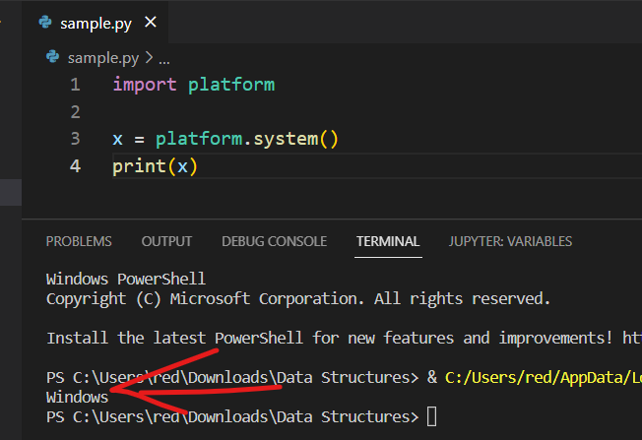

### Using the dir() Function

There is a built-in function to list all the function names (or variable names) in a module. The ***dir()*** function:

**Example**

List all the defined names belonging to the platform module:

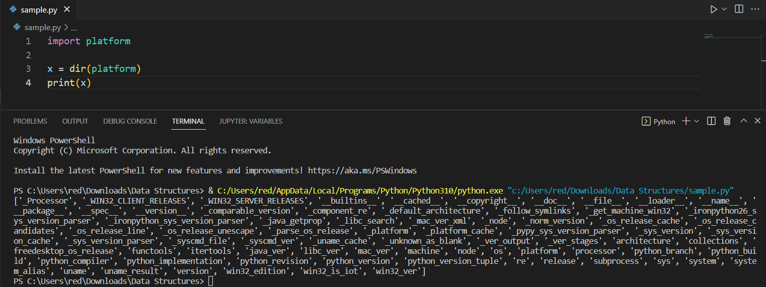

Note: The dir() function can be used on all modules, also the ones you create yourself.

### **Python Dates Module**

A date in Python is not a data type of its own, but we can import a module named datetime to work with dates as date objects.

**Example**

Import the datetime module and display the current date:

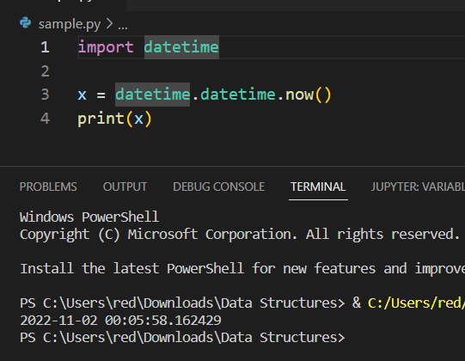

## Import From Module

You can choose to import only parts from a module, by using the ***from*** keyword.

**Example**

The module named ***mymodule*** has one function and one dictionary:

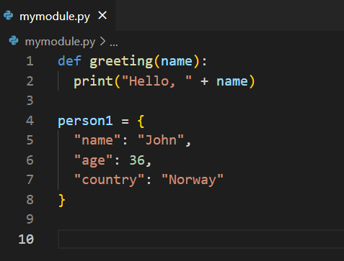

**Example**

Import only the person1 dictionary from the module:

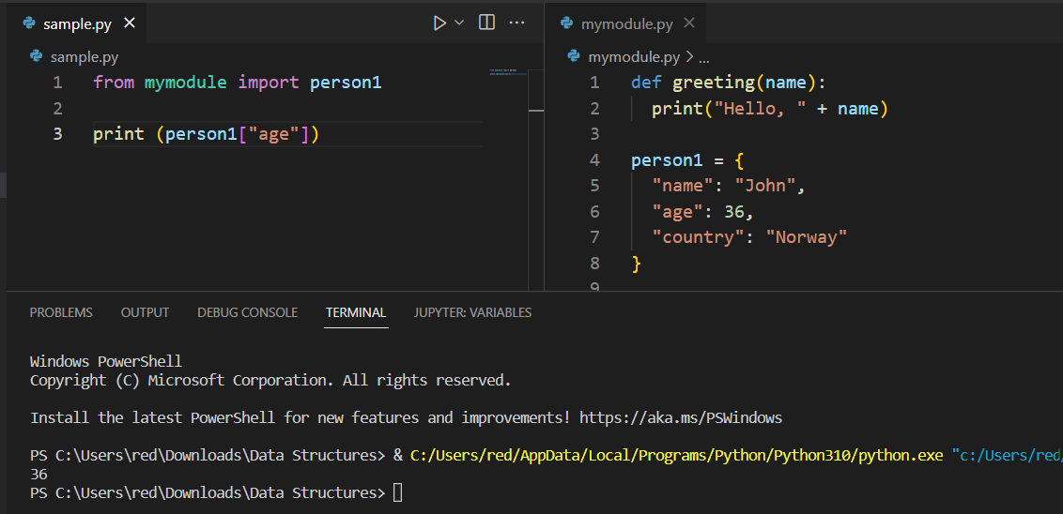

Note: When importing using the from keyword, do not use the module name when referring to elements in the module. Example: person1["age"], not ~~mymodule.person1["age"]~~

# Packages

* Collection of modules (directory with different modules or python files)

When developing a large application, you may end up with many different modules that are difficult to manage. In such a case, you’ll benefit from grouping and organizing your modules. That’s when packages come into play.

Python packages are basically a directory of a collection of modules. Packages allow the hierarchical structure of the module namespace. Just like we organize our files on a hard drive into folders and sub-folders, we can organize our modules into packages and subpackages.

To be considered a package (or subpackage), a directory must contain a file named __init__.py. This file usually includes the initialization code for the corresponding package.

For example, we can have the following package my_model with modules related to our data science project:

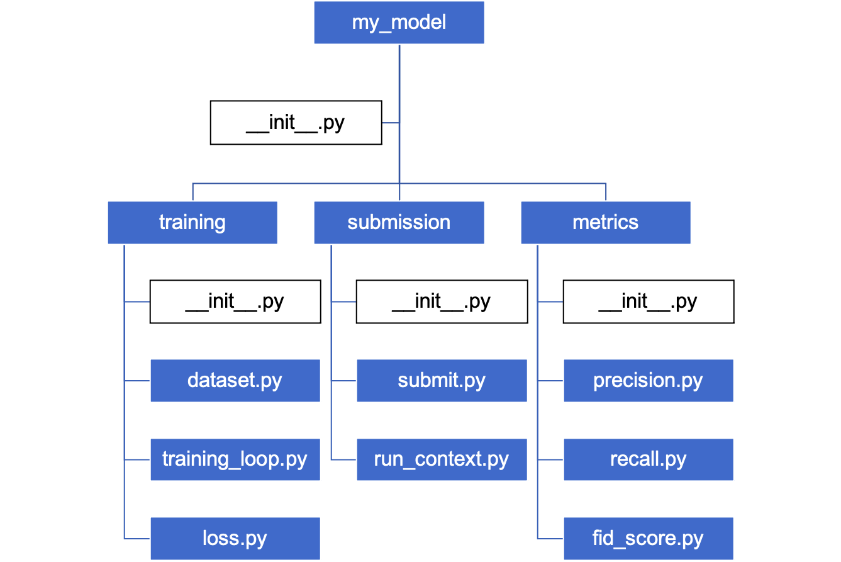

We can import specific modules from this package using the dot notation. For example, to import the ***dataset*** module from the above package, we can use one of the following code snippets:

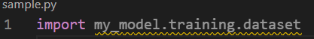

There are a lot of ***built-in and open-source Python packages*** that you are probably already using.

For example:

* [**NumPy**](https://numpy.org/) is the fundamental Python package for scientific computing.
* [**pandas**](https://pandas.pydata.org/) is a Python package for fast and efficient processing of tabular data, time series, matrix data, etc.
* [**pytest**](https://pypi.org/project/pytest/) provides a variety of modules to test new code, including small unit tests or complex functional tests.

# **Library**

**A library is an umbrella term referring to a reusable chunk of code.** Usually, a Python library contains a collection of related modules and packages. Actually, this term is often used interchangeably with “Python package” because packages can also contain modules and other packages (subpackages). However, it is often assumed that while **a package is a collection of modules, a** **library is a collection of packages**.

Oftentimes, developers create Python libraries to share reusable code with the community. To eliminate the need for writing code from scratch, they create a set of useful functions related to the same area.

There are thousands of useful libraries available today. I’ll give just a few examples:

* [**Matplotlib**](https://matplotlib.org/) library is a standard library for generating data visualizations in Python. It supports building basic two-dimensional graphs as well as more complex animated and interactive visualizations.
* [**PyTorch**](https://pytorch.org/) is an open-source deep-learning library built by Facebook’s AI Research lab to implement advanced neural networks and cutting-edge research ideas in industry and academia.
* [**pygame**](https://pypi.org/project/pygame/) provides developers with tons of convenient features and tools to make game development a more intuitive task.
* [**Beautiful Soup**](https://www.crummy.com/software/BeautifulSoup/bs4/doc/) is a very popular Python library for getting data from the web. The modules and packages inside this library help extract useful information from HTML and XML files.
* [**Requests**](https://docs.python-requests.org/en/master/) is a part of a large collection of libraries designed to make Python HTTP requests simpler. The library offers an intuitive JSON method that helps you avoid manually adding query strings to your URLs.
* [**missingno**](https://github.com/ResidentMario/missingno) is very handy for handling missing data points. It provides informative visualizations about the missing values in a dataframe, helping data scientists to spot areas with missing data. It is just one of the many great [Python libraries for data cleaning](https://learnpython.com/blog/python-libraries-data-cleaning/).

By the way, the **NumPy** and **pandas** packages that were mentioned before are also often referred to as libraries. That is because these are complex packages that have wide applications (i.e. scientific computing and data manipulation, respectively). They also include multiple subpackages and so basically satisfy the definition of a Python library.

# **Python Frameworks**

Similar to libraries, Python frameworks are a collection of modules and packages that help programmers to fast track the development process. However, frameworks are usually more complex than libraries. Also, while libraries contain packages that perform specific operations, **frameworks contain the basic flow and architecture of the application**.

If you compare application development to house construction, Python frameworks provide all the essential building blocks like the foundation, walls, windows, and roof. Then, the developers build their application around this foundation by adding functionalities comparable to a house’s alarm system, furniture, appliances, etc.

For a better understanding, let’s review several popular frameworks:

* [**Django**](https://www.djangoproject.com/) is a Python framework for building web applications with less coding. With all the necessary features included by default, developers can focus on their applications rather than dealing with routine processes.
* [**Flask**](https://flask.palletsprojects.com/en/2.0.x/) is a web development framework that is known for its lightweight and modular design. It has many out-of-the-box features and is easily adaptable to specific requirements.
* [**Bottle**](https://bottlepy.org/docs/dev/) is another lightweight framework for web development that was originally meant for building APIs. Its unique features are that it has no dependencies other than the [Python Standard Library](https://docs.python.org/3/library/) and it implements everything in a single source file.

Python frameworks allow programmers to streamline the web development process by providing a necessary foundation while still being flexible. No wonder that top applications – including Netflix, Airbnb, Reddit, and Udemy – leverage the benefits of Python frameworks.

# Package Manager

What makes Python a true power tool is the ecosystem of **free and open source** **libraries** like Tensorflow, Netmiko, and Flask. These can be **installed** with a **single command** using a **package manager**.

## PyPI: The Package Index

Similar to [NuGet.org](https://www.nuget.org/)& [Npmjs.org,](https://www.npmjs.com/) Python also has its own official third-party software repository. [The Python Package Index](https://pypi.org/) (PyPI) is a repository of software that hosts an extensive collection of Python packages, development frameworks, tools, and libraries.

PyPI packages allow developers to share and reuse code rather than having to reinvent the wheel. As PyPI grew, the need for a package manager became so apparent that Python eventually created its own standard package manager: pip.

## Pip: The Standard Package Manager

[Pip](https://pypi.org/project/pip/) is built-in to Python, and can install packages from many different sources. But PyPI.org is the primary and default package source used.

By default, pip installs packages onto a project’s global [Python environment](https://docs.microsoft.com/en-us/visualstudio/python/managing-python-environments-in-visual-studio?view=vs-2022)resulting in packages being accessible by all projects. This can be an issue due to packages being dependent on specific versions of other packages. Since all packages are in a global environment, its easy to run into a dependency conflict that may prevent your application from building.

Thankfully, pip automates package management by first resolving all dependencies then proceeding to install the request packages. However, the standard method for preventing dependency conflicts is to create separate Python environments for each project.

## Pip Alternatives (Pipenv & Poetry)

Pip is the “original” python package manager that others have attempted to improve upon. Pipenv & Poetry are two package managers that have done this with great success.

[Pipenv](https://pipenv.pypa.io/en/latest/) is a package management tool that “aims to bring the best of all packaging worlds” to Python. Pipenv is similar in spirit to Node.js’s [npm](https://www.npmjs.com/) and Ruby’s [bundler](https://bundler.io/). It’s popular among the Python community because it merges virtual environments and package management into a single tool. While pip is sufficient for personal use, Pipenv is recommended for collaborative projects as it’s a higher-level tool that simplifies dependency management for common use cases and can create virtual environments.

[Poetry](https://python-poetry.org/) prides itself on making Python packaging and dependency management “easy”. Besides package management, it can help build distributions for applications and deploy them to PyPI. It also allows the declaration of the libraries a project depends on and installs/updates them avoiding any conflicting package requirements. Furthermore, Poetry isolates development versus production dependencies into separate virtual environments.

## Conda: Alternative Package Management

[Conda](https://docs.conda.io/projects/conda/en/latest/) is a multi-purpose package management tool. It manages package dependencies, can create virtual environments for applications, installs compatible Python distributions, and packages applications for deployment to production. It originated from [Anaconda](https://www.anaconda.com/products/individual), which started as a data science package for Python. Conda installs packages from Anaconda rather than PyPI and can be used with multiple programming languages.

Compared to Pip, the package selection is much smaller, but what Conda lacks in quantity it makes up for in quality. Anyone can publish to PyPI, but only packages curated by Anaconda are published in its repository. While Anaconda requires a paid subscription, it grants access to thousands of curated packages and provides support as well. Conda is an ideal package manager for those that are willing to pay to not worry about license, quality, and vulnerability issues when dealing with third party/open-source packages.

References:

<https://learnpython.com/blog/python-modules-packages-libraries-frameworks/>

<https://blog.inedo.com/python-managing-python-packages>

<https://www.w3schools.com/python/python_functions.asp>

# Object-Oriented Programming

* Is a method or approach of organizing a program by grouping properties, methods, attributes into individual objects.

## Class

* Is the blueprint or template for creating instances and objects; helps us organize our data and functions so that they can be reused or modifies if necessary.

## Objects

* Are data structures that are defined by its class, comprised of methods, class variables, and instance variables.

## Attributes

* Are data stored inside a class or instance that represent the state of the class or instance.

## Methods

* Are a type of function that is defined in a class.

## Class Variables

* Are variables that are used by all instances of the class, which can be defined within a class, but not within the methods of the class.

## Instance Variables

* Are variables that are defined within a method and are unique to a certain instance.

## __init__ method

* Is used to assign values to the properties and operations of objects when it is being created.

## Inheritance

* In object-oriented programming (OOP), inheritance “allows classes to have code reusability within programming”.

## Subclass

* Is the class which inherits from another class, also called a child class.

## Base Class

* Is the class being inherited from, also called parent class.

## Method Overriding

* Is used to change what the method does. Within the subclass, we redefine the method (with the same name) to perform the task differently.

## Super() Method

* Is a method that “allows you to call a method from the parent class.”

# **Error Handling**

## **Try**

* Try is used to test a block of code for errors.

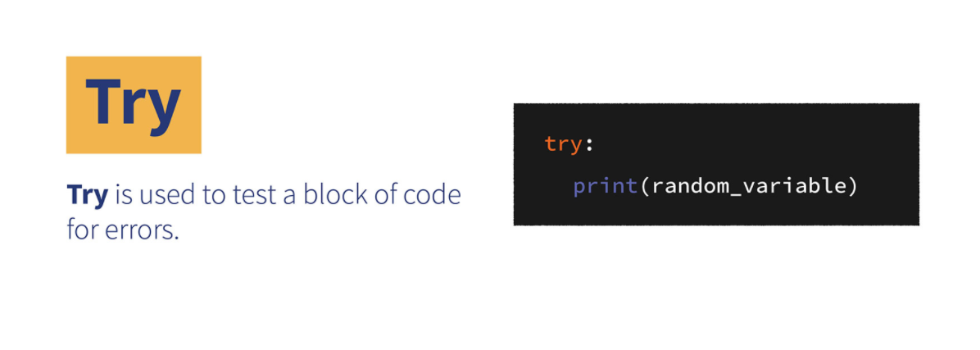

## **Except**

* Except allows users to handle the errors encountered during the try block.

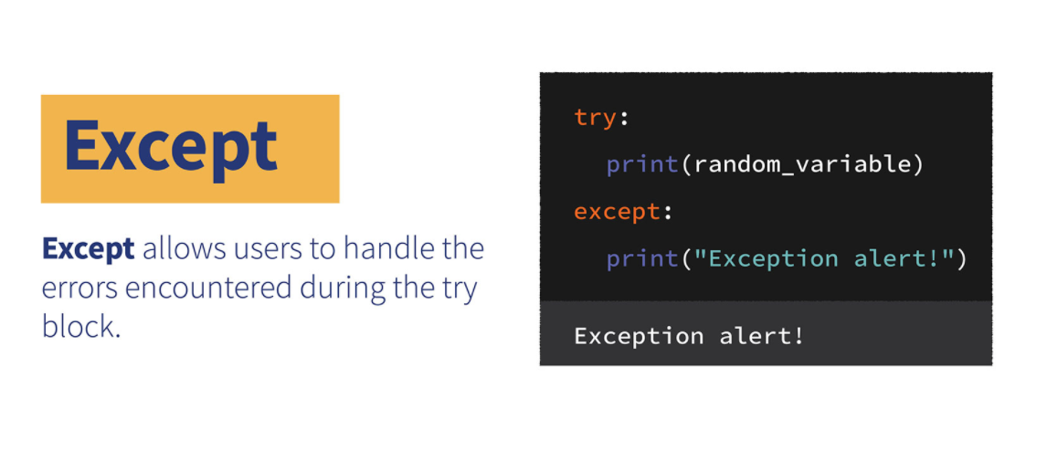

## **Raise**

* Raise keyword allows users to define what kind of error will result upon running the code, as well as the text printed on the console.

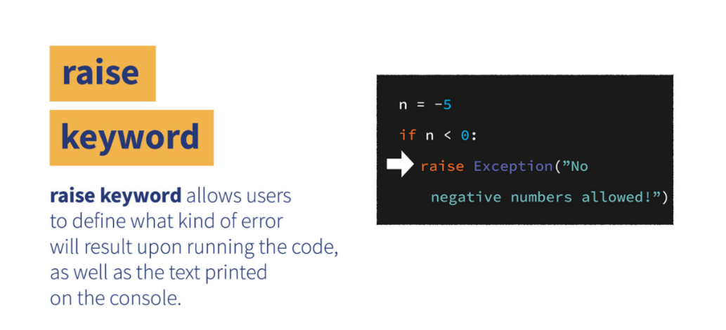

## **Exception**

* Ise used to “manage errors that arise during a program’s execution. Whenever an error occurs that makes Python unsure what to do next, it creates an exception object”.

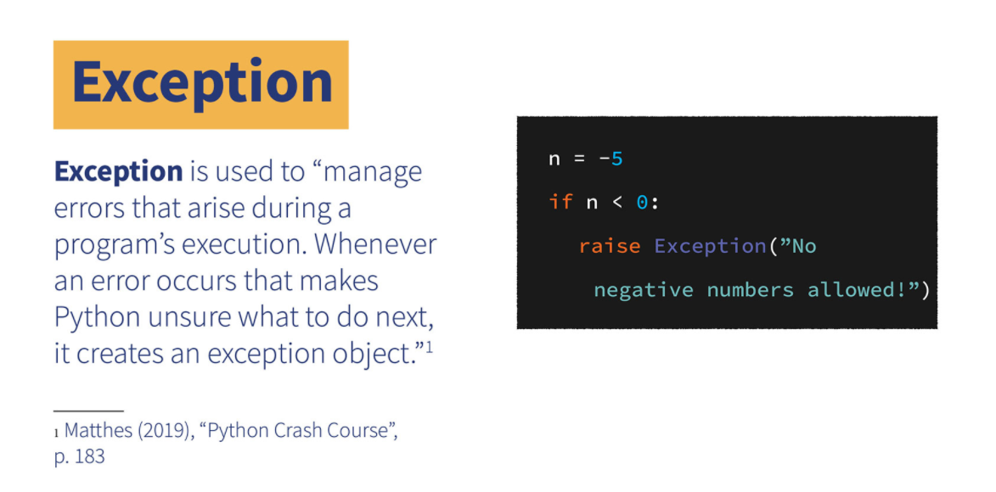

## **Finally**

* Finally runs the code despite any errors or exceptions encountered.

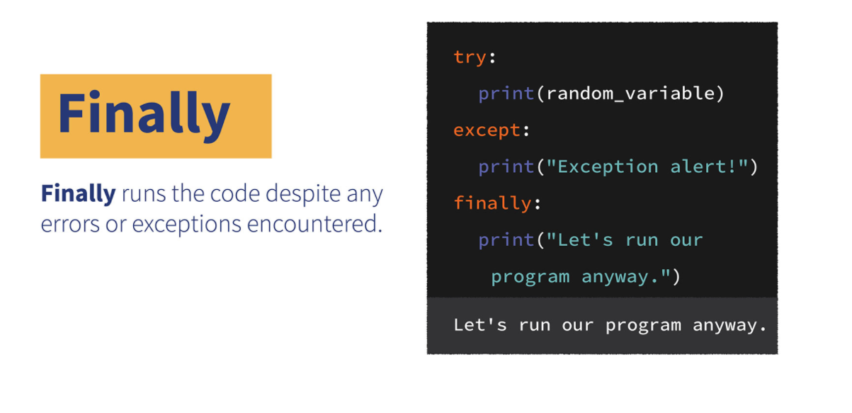

# File Handling

Allows the user to read, write, update and delete files.

The reader will also appreciate the fact that the main memory is volatile. The data produced by a program cannot be used for future endeavors. Many times it is required to store the data for use in future. For example, if one develops a student management system, the user should be able to retrieve the data as and when required.

## THE FILE HANDLING MECHANISM







## File opening modes in Python

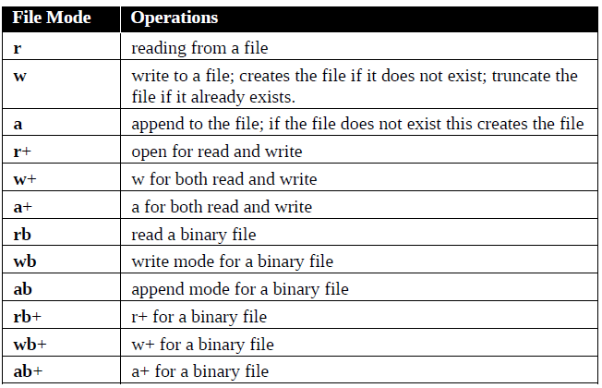

## PYTHON FUNCTIONS FOR FILE HANDLING

Python provides various library functions to carry out the standard tasks. The functions help us, say, to read from a file, write to a file and to append something in the existing file. Moreover, Python also provides the programmer with functions to take the cursor to a particular location, or to read from a given location.

**Allows user to read, write, update, and delete files:**

* Open() – to open a file and returns a file object
* Read(), readline() – read content of the file
* Write() – to write to an existing file
* Close() – close the file
* Delete() – remove files

### Open File

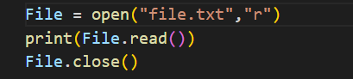

### Write to a File



### Remove File

